**ORIGIN AND GROWTH OF THE TOWN**

**HISTORICAL BACKGROUND**

The study area is influenced by the life style of citizens of Lagos state, people from Bariga, Shomolu, Ilaje and Yaba. Shomolu is a very high density area comprising Gbagada phase I and II, Akoka, Bariga, Shomolu, pedro, igbo – igunni and others, somolu came into existence since 1905; the entire shomolu was under ikeja divisional council then which was in the colony province of western region. Shomolu was also an integral part of then mushin district council until 1976 when shomolu became an autonomous local government area, Odumosu, 1999. Shomolu local government came into existence following the local government review of 1976 by the Obasanjo regime.

**RELIGION**

Residents of the study area practice Christianity, Islam and few percentages are traditional rulers.

**ADMINISTRATION**

The study area is under three administrative divisions (Shomolu, Lagos Mainland and Lagos Island)

**EDUCATION**

Lagos state government operates state schools and the education system is the 6-3-3-4, which is practiced throughout the whole country. The levels are primary, junior secondary school, senior secondary school and university. List of some of the schools in shomolu include:

1. Binta Girls High School
2. CMS Grammar School
3. Igbobi College

**SIGNIFICANT LANDMARKS IN ITS EVOLUTION**

There are not too many landmarks in Shomolu, some of the few includes;

* **CMS Grammar School, Lagos**

The CMS Grammar school in the Bariga district of Lagos is the oldest secondary school in Nigeria, founded on the 6th of June 1859 by the Church Missionary Society. For decades it was the main source of African Clergymen and administrators in the Lagos colony.

* **Yaba College**

Yaba Higher College was founded in 1932 in Yaba, now a suburb of Lagos in Nigeria to provide tertiary education to Africans, mostly in vocational subjects and teaching. The College staff were transferred to start the University of Ibadan in 1948 and the college premises were used for the new Yaba College of Technology.

* **Bariga**

Bariga is a district and a suburb in Somolu local government area of Lagos State. Headquartered in Gbagada. It is known to be the location of the oldest secondary school in Nigeria.

**HISTORICAL AND CULTURAL HERITAGE OF THE PEOPLE**

Shomolu, also spelled Somolu town, Lagos State, southwestern Nigeria, just north of Lagos city. A residential suburb of Lagos, the town is plagued by problems of overcrowding, poor housing and inadequate sanitation. Most of its inhabitants are Yoruba. The town’s local activities include work in leather, handicrafts and printing. The population of the LGA according to 2006 census is 402,673.

They are known today as Somolu Local Government area was formerly known as Mushin East Local Government area when it was carved out and became Kososfe Local Govt. 2003. Bariga area was again carved out and became Bariga Local Govt. while the remaining area retained Somolu Local Government.

The Local Government Headquarters is located at 2 Durosinmi street Somolu off Oguntelu. The present Somolu Local Government comprises areas like the community Road, Akoka. Areas east of Ikorodu road up tonthony Oke side interchange, including Somolu, Bashua, Bariga, part of Akoka, Igari, Obanikoro, Pedro village, Abule Okuta, Seriki village, Apelehin, Ilaje.

The Somolu Local Government is essentially inhabited by the Yorubas, prominent among them are the Ijebus, Egbas, Awories and Ilaje. Other groups such as Oyo, Osun and Ekiti are represented in the area. However, other ethnic groups from the East and Nothern parts of the country are equally large in number in the Local Government Area.

While the community in time past has been embroiled in violence and disorder (one which could equally be attributed to the failure of the society to provide viable alternatives), a new and different mentality is feeding a much more proactive and positive temperament. Unfortunately, in their case, as in the case of many youths in the continent, this energy until now, has been channelled to wrong use. However, this is changing, heralded by the many artistic initiatives by equally proactive individuals.

To the people of Somolu, the canal which runs from Somolu to Folagoro, Akoka, etc. is a symbolic divider. It is popularly known as “middle belt” by the indigenes as it serves as neutral ground and often a space of demarcation between the two most Important factions of the community’s gangs.

Somolu is the biggest printing hub in Nigeria and is complemented with other commercial activities such as trade of foodstuffs, utilities etc.

Somolu is a town in Metro Lagos, southwestern Nigeria, just north of Lagos city. A residential suburb of Lagos, Nigeria.

**Somolu in its geographical setting**

**National context**

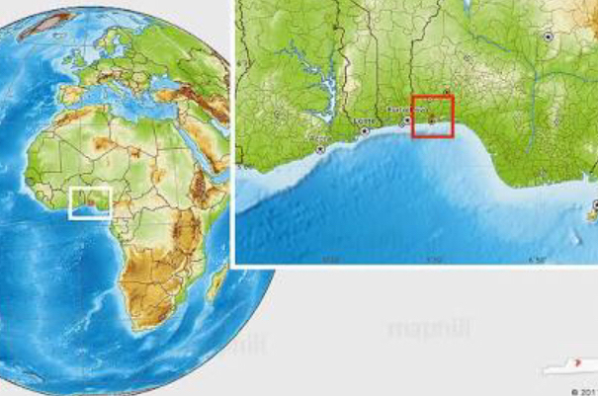

Figure 2.0: The globe showing africa, west africa and the location on Nigeria in west africa

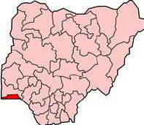

Figure 2.1: the map of nigeria showing the location of lagos

The federal republic of Nigeria as rightly called is a country in west africa of the world having a border with cameroon and chad in th east, benin in the west and niger in the north. It is a country that has 36 states including the federal capital territory which is abuja. The official languages spoken in nigeria is english with major languages being yoruba, igbo and hausa. Nigeria covers a total land mass of 923,768km2 with a total population of 185,989,640 (estimated) in contrast to 140,431,790persons as generated from 2006 national population census having a populatio density of 197.2/km2.

Nigeria is often reffered to as the giant of africa located on the gulf of benin and it’s the 32nd largest country after tanzania in the world. The lanscape of Nigeria varies with its southeastern and southwestern area having coastal plains and tropical rainforest climate predominant in the south having an average rainfall of 60 to 80 inches which is about 1500-2000mm in a year.

In the north, nigeria has a fresh water swamp containing different vegetation from the salt water swamp otherwise reffered to as the mangroove. It has its most expensive topographical region in the valleys of niger and benue river in which niger hras rugged highlands and to the southeast of benue there are hill and mountains. The south majorly has a covering of tress, grasses,shrubs and flowers.

Out of the 36 states in Nigeria lagos remains the most populated with a population of 8,048,430 people and it serves also as the commercial centre of Nigeria due to the presence of various large commercial activities in it.

|  |  |
| --- | --- |
| City | Population |
| Lagos | 8,048,430 |
| Kano | 2,828,861 |
| Ibadan | 2,559,853 |
| Benin city | 1,147,188 |
| Port harcourt | 1,005,904 |

*Source: wikipedia*

Table 1.0: showing major cities in Nigeria and their population

**Regional context**

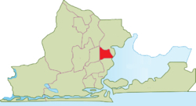

Figure 2.2: map of Lagos showing somolu local government area

Lagos is termed as the largest city in Nigeria, Africa and one of the fastest growing mega cities in the world with a notable urban agglomeration. It is the commercial hub of Nigeria which makes it a major financial center in Africa.

Lagos growing as a port city is a combination of islands which are separated by creeks in which some of the islands have become the present day Lagos island, Eti-osa, apapa, amuwo-odofin etc. Lagos is classified into two which is a function of the extension from the water base communities to dry lands which are Lagos island and the mainland

‘it was a city governed directly by the Federal Government through the Lagos City Council, until the creation of Lagos State in 1967, which led to the splitting of Lagos city into the present day seven Local Government Areas (LGAs), and an addition of other towns (which now make up 16 LGAs) from the then Western Region, to form the state’- wikipedia.

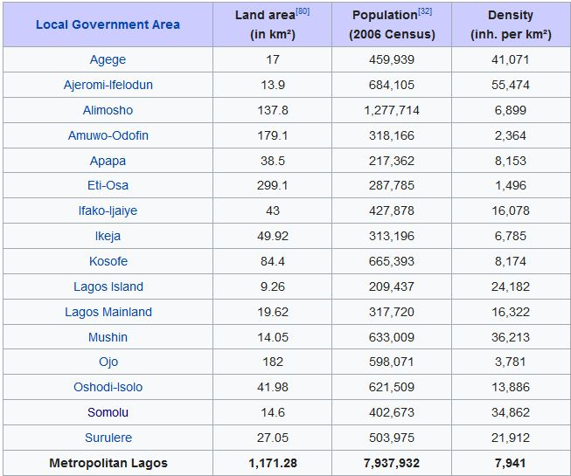

Source:Wikipedia

Table 1.2: showing local governments in Lagos state

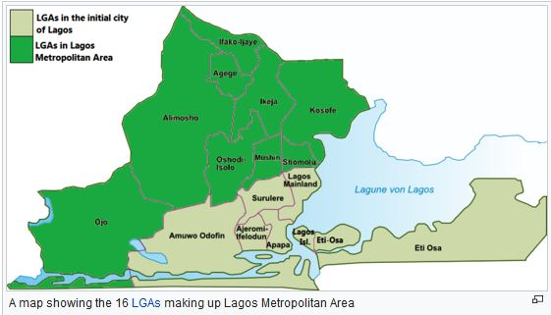

Figure 2.3: map of Lagos showing local government areas in Lagos state

The geographical conditions, nature of soils, building materials locally available.

The climatic condition of Lagos is analyzed below in the table

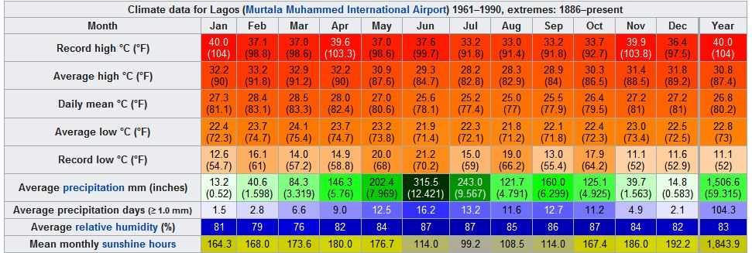

Table 1.3: showing the climatic condition of Lago

Somolu local government area is one of the local government areas in Lagos state which has one of the highest populations amongst the local government areas in Lagos state.

**Land mass, population and physical extent**

The population development of Shomolu as well as related information and services. Lagos state has a density of 3,577 km2 (1,381 sq mi) and a population of 9,113,605 people as at 2006 and in 2012 estimated to be 17,552,940 people. Somolu being a local government in Lagos State land mass is 12.1km, Water area is 2.5km, with a total of 14.6km.

**SITE ANALYSIS IN THE STUDY AREA - (Shomolu 1)**

**BASE MAP**

The base map is an initial map that is gotten from the site, it provides back-ground, or reference info in a map. It is used to provide visual reference to other maps. Street maps, terrain and aerial imagery are examples of base maps. It also depicts background reference information such as landforms, landmarks, political boundaries and roads. It serves as the basis in which a place could be designed. The base map below shows a part Mushin and the existing features in it which are: roads and buildings.

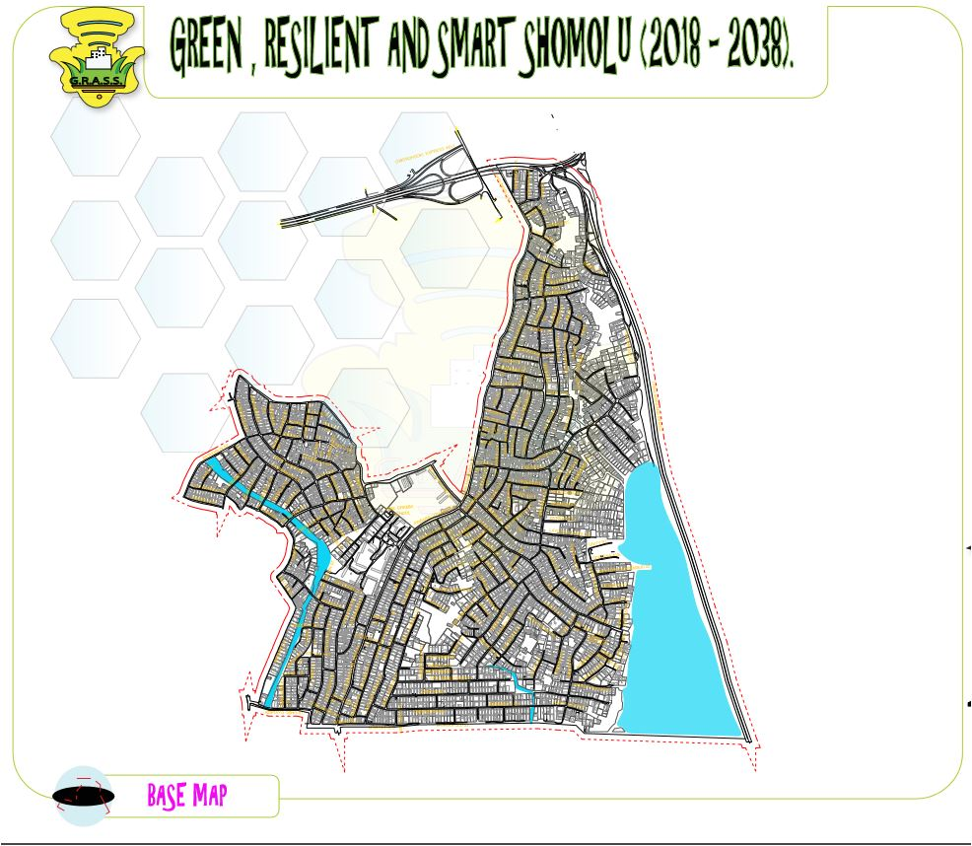

**UPDATED BASE MAP**

As the name implies, an updated map is map that has been made up to date with all the features of the site that were not formerly in the base map. i.e. the features that are not present on the base maps are put into it.

There are two ways by which this can be achieved:

1. Reconnaissance method
2. In-car method

**Reconnaissance method:** this requires the performing of a recon of the site by moving on foot while updating the information in the area

**In-car method:** this involves scouting the area in a moving vehicle while updating the area.

The method used for this site was the reconnaissance method and some of the updates that were observed are listed as follows:

1. Some roads that were shown to have joined at a junction just ended abruptly
2. Some roads do not exist anymore
3. Some roads exist on site but not on the base map

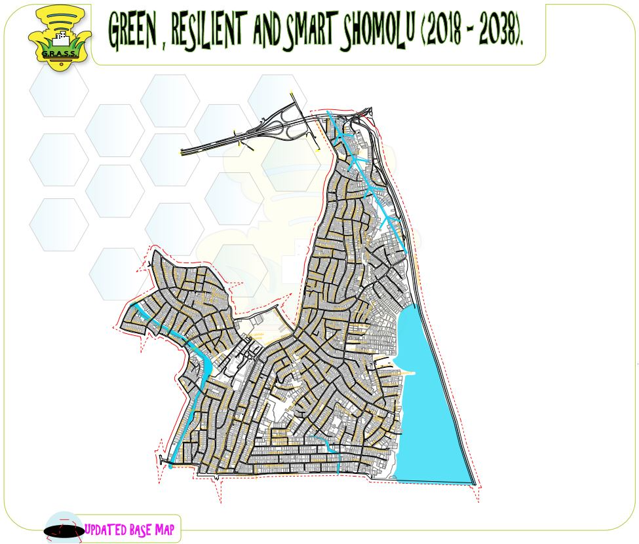

**CLIMATIC ANALYSIS**

**Micro Climatic Element:**

As a result of the location of shomolu and its environs on the latitude, the entire area has the characteristic of the West African Monsoonal Climate, marked by distinct seasonal shift in the wind pattern. Although, some very few months are not humid, there is no month that is dry and in which rainfall is not well over 2000 millimeters. The location is also under the general circulatory patterns in the tropical equatorial areas, which is associated with the apparent movement of the sun and the relative position of the Intertropical Discontinuity (ITD). The front between the prevailing two air masses (the maritime southwest winds and the dry Northeast winds from the continental origin)

Thus, the climate is determined largely by the influence of these two air masses; the south-westerly monsoon winds and the north easterly winds. The former is due to the hot and humid tropical maritime air mass blowing from the Atlantic Ocean, while the latter are due to the warm and dry air mass from the Sahara Desert, in the north. These two air masses are separated by a zone of discontinuity called Inter Tropical Convergence Zone (ITCZ). This zone moves north-south following the movement of the sun.

**Temperature:**

The temperature pattern over the project area is influenced largely by movements of ITCZ, the wind direction, position relative to the equator and distance from the sea. It is worthy to note that because of its location within the equatorial belt, the project area experiences double temperature and rainfall maxima annually. Highest annual temperature is obtained between March and April and also between November and December. These two peaks can be explained in terms of movement of the sun.

annual temperature pattern over the project area however reveals a minor fall in temperature due to influence of Harmattan, (a cool dry and dusty wind from Sahara Desert). The harmattan is prevalent between December and February: while the second fall in temperature coincides with the peak of rainfall in July. The reduction in air temperature is due to the impact of the southeast moisture laden monsoon wind that blows over the entire equatorial area during this period. The mean annual temperature ranges between 24°C and 32°C, while the mean monthly minimum and maximum temperature are 24.2°C and 30.0°C and the daily temperature range is 27°C. The table below provides information on the temperature pattern in the project area.

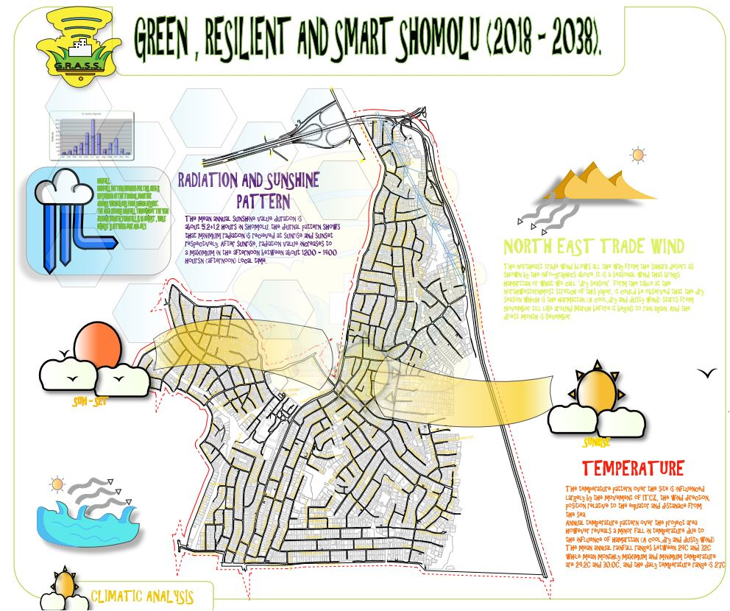

**Pattern of Rainfall in the Project Area**

|  |  |  |  |  |  |  |  |  |  |  |  |  |
| --- | --- | --- | --- | --- | --- | --- | --- | --- | --- | --- | --- | --- |
| **Parameter** | **Jan** | **Feb** | **Mar** | **Apr** | **May** | **Jun** | **Jul** | **Aug** | **Sep** | **Oct** | **Nov** | **Dec** |
| **Rainfall(mm)** | 28 | 46 | 99 | 145 | 277 | 450 | 267 | 66 | 142 | 208 | 69 | 25 |

***Source****: Meteorological Department (2013)*

**Rainfall:**

Rainfall pattern in the project area can be explained in terms of the movement of the ITCZ. This movement explains the observed double rainfall maxima which characterizes the project site. The proposed project area is influenced by tropical maritime air mass, which blows from the Sahara Desert, while the former brings rain, the latter brings dusty harmattan to most part of West Africa. In fact, as a result of its relative location, the area records rainfall almost throughout the year. The apparent movement of the sun over the equator twice in a year is responsible for the occasional and localized rainfalls that are experienced over the area throughout the year. The average monthly rainfall is in August, while the highest monthly rainfall is between June and July and September and October. The table shows the rainfall distribution pattern on a monthly basis in the project area.



Source: Nigerian Meteorological Agency, 2013

Mean Monthly Rainfall in the Project Area

**Radiation and Sunshine Pattern:**

Radiation and Sunshine pattern over the project is similar to the observed pattern of rainfall and temperature. For example, the regime is also characterized by two maxima and two minima in consonance with the apparent movement of the sun. The mean annual sunshine value duration is about 5.2+1.2 hours in Shomolu. The diurnal pattern shows that minimum radiation is received at sunrise (morning) and sunset (evening) (Ojo, 1977). After sunrise, radiation values increase to a maximum in the afternoon between about 1200 and 1400 hours (afternoon) local time.

While the variation in radiation received during the afternoon period is significantly, there is a very marginal variation in the annual radiation values obtained in the morning and evenings.

**LAND-USE ANALYSIS**

The dominant land use within the action area is residential, although it should be noted that within many residential properties, ancillary commercial activities also often take place.

Along St. Finbarr’s road, the land use is more varied with a wide mix of residential, commercial, educational, health and governmental land. This wide variety is to a large part a consequence of the efficiencies and adaptability of the regular grid structure of the area.

Within the olanrewaju road area, the dominant land use activity is industrial, with the area housing a number of spare parts warehouse and auto-painting industries. Additionally, a variety of associated commercial enterprises have developed on the back of the auto- painting industry, i.e. furniture making, retail shops, etc. Ancillary residential land uses can also be found in the area.

The Ilaje slum is dominated by residential land uses, although it is recognized that there are significant ancillary commercial activities also taking place within the area. The Ilaje slum is well known for its smoked fish industry, and as a consequence the area is often shrouded in wood smoke from these activities. A range of public facilities such as schools, religious buildings and health centers, which serve the population of the slum area, have developed along the original waterfront. The recent construction of floating health and education facilities over the lagoon, represent the latest efforts by the State Government, to address the deficiencies of service provision across the area

**Existing building condition:**

Building conditions reflect the character of different sections of the action area. Shomolu has a complex mixture of all types of building conditions from good to dilapidated which varies sometimes on a plot by plot basis, with buildings of a good condition found beside those in a dilapidated condition.

Ilaje and Bariga, by comparison, are dominated by buildings in poor and dilapidated conditions, reflecting the slum and heavy residential nature of the areas.

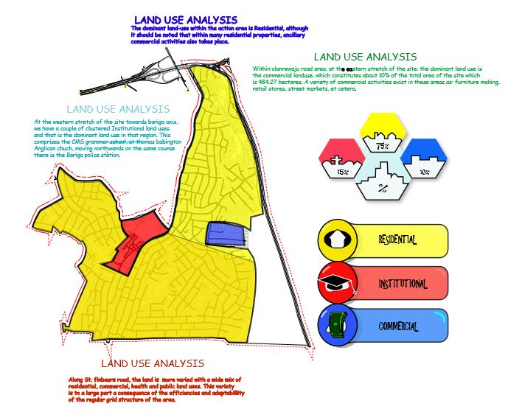

**Existing building material:**

As with building height and condition, the dominant building materials reflect the character of different sections of the action area. The buildings in shomolu are generally constructed in solid masonry, cement block/ concrete, with a small number of brick built structure.

In contrast, development in the Ilaje slums and at Bariga, are for the most part constructed out of timber/ bamboo. In particular, development over the lagoon, such as can be seen in Makoko has to be constructed in a light weight material like timber. With piecemeal land reclamations often being undertaken by individual property owners, more solidly constructed buildings are likely to be seen in the future in these areas.

**ROAD ANALYSIS, HIERACHY AND CONDITION**

The existing road network comprises of a mostly local (tertiary) road and water lane system, bordered to the west by the Lagoon and the third mainland bridge, to the east by Bariga, and to the North by Oworonshoki.

Clinic Road is generally inaccessible within the action area as it is mostly elevated and has a single junction at Herbert Macaulay Road. The road creates a physical barrier between the north and south halves of the action area, preventing north-south movements between shomolu and Bariga.

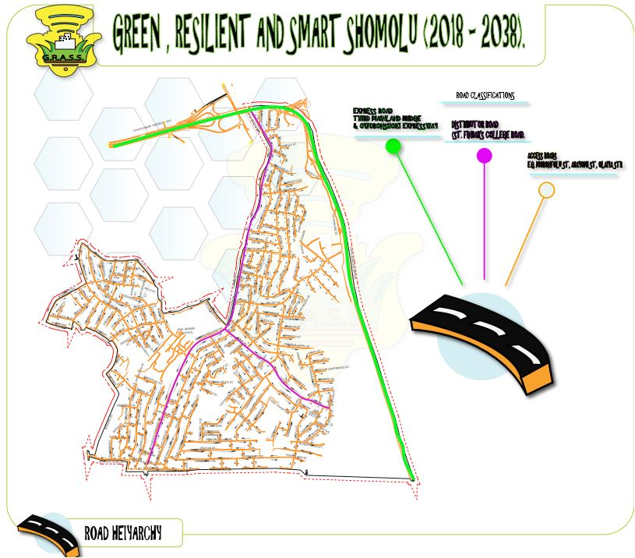

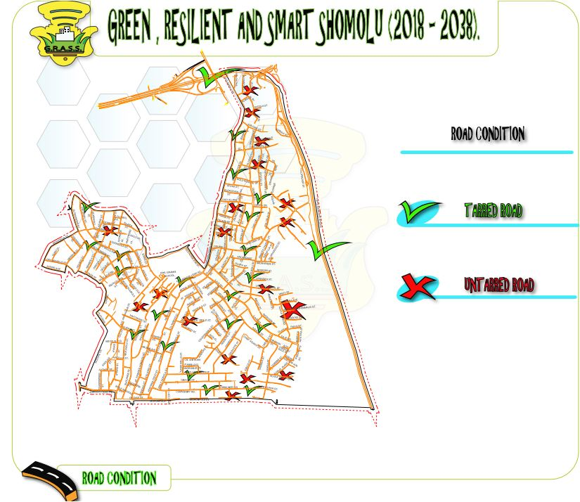

Shomolu has an established local (tertiary) road network which serves this area well. However, there is no functioning road network hierarchy, and few roads throughout the Ilaje slum. Vehicular access into the ghetto area is currently very poor and the majority of Makoko is only accessibly by way of water transport.

The area is generally poorly served by public transport. While small buses operate within shomolu, they cannot service the inner parts of Ilaje and makoko due to the lack of roads. The residents of Makoko, however, are able to exploit the area’s relationship to water with water taxis services (canoes) able to transport people and services.

**FLORA AND FAUNA ANALYSIS**

**Vegetation (Flora):**

The natural vegetation of Shomolu its environ falls in the humid forest classification. Specifically, it is in the lowland rain forest category. The forest consists of tall trees with continued canopy of foliage and deep shade for the underground layers. In the area, most of the natural vegetation has changed into secondary ones with recognizable physiognomy.

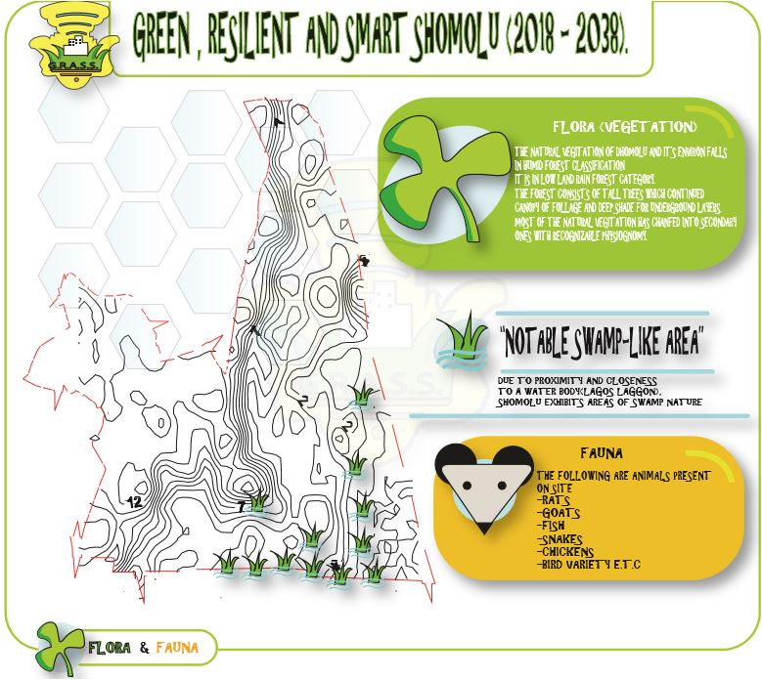

Going by the vertical structure of the typical rainforest there ought to be five layers. These are: the upper, middle, lower, shrub and ground strata. However, for the Planning Area, the layers are incomplete in some parts. This is traceable to relatively high human activities including farming and urban development efforts.

For instance, at around a distance of between 500 meters to one kilometre of the built up part of shomolu towards Adedoyin oshinbajo Road, there are the upper, lower, shrub and few ground strata. The trees at the upper layer consist of tall isolated emerged trees, with height of between 40 and 50 meters, since these trees are isolated, the formation of continued canopy becomes impossible. For the lower stratum, the trees have heights of between 10 and 16 meters with continued canopy. The same scenario occurs towards the end of community road in the south eastern axis of the project area. Some of the local trees species found in shomolu are: *isotomia, Bonei, Anthocleista, Vogeli and Symphoria Globilifera.*

Vegetation belt of shomolu

lulu

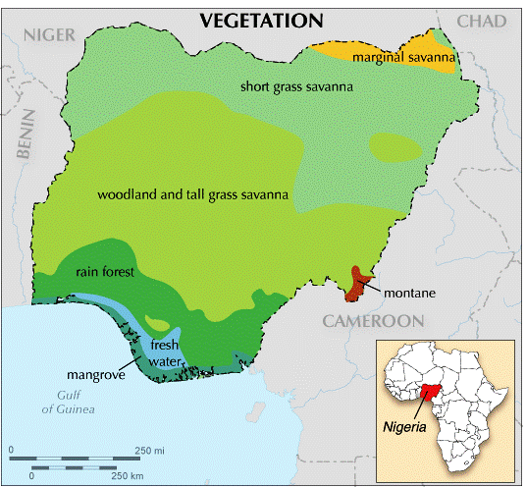

**SHOMOLU**

Since the gneiss is the dominant rock type in the area, the derivative minerals are quartz, biotite and chlorite. In addition, clay is the most popular minerals identified in the Planning Area. It occurs in virtually all parts of shomolu and its environ.

**Geology and Soil Analysis:**

A thorough observation on the geology and soil of the site was made. This indeed provided information

for the Master plan work particularly with regards to physical planning/ land use, design of infrastructure, including buildings, particularly roads, drains and others within the project area. The geology of the sub-region indicates that it is comprised largely of the basement ground, which is part of the African Crystalline Shield. This basement ground dominates South-Western Nigeria and it consists of gneisses, schist and quartzite's. The Site is located on sedimentary rock formation, which itself is underlain by the crystalline basement complex.

Geologically, the Ilaje Local Government and its environ, fall in the recent coastal deposits strata which consists of littoral and lagoon sediments of the coastal belt and the alluvial deposits of major river.

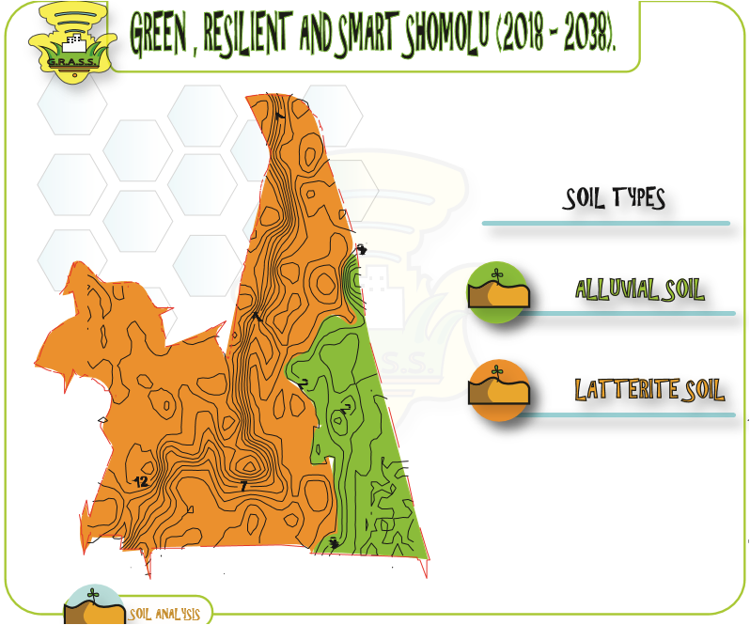

In addition, other studies on the soils and sub-soil characteristics of shomolu axis revealed that the sub-soil type of the axis is in the recent littoral and lagoon deposits category. Soils in this category vary widely from soft and / or loose deposits, through to stiff deposits: clay and sandy, silty clays and dense deposits (sands, clayey-sands and gravels). The distribution of sediments of the recent littoral and lagoonal deposits is believed to have exposed the area to high possibility of encountering soft and / or loose deposits at variables proportion with severe implication in areas with soft, near surface sub soils.

**Fauna:**

Fauna in shomolu includes rats, cats, fishes, dogs, and fowls.

**TOPOGRAPHY ANALYSIS**

**Terrain and Topography:**

The geology and soil characteristics of the axis gave rise to the terrain and the topography that has evolved. Accordingly, the terrain is a mix of sandy texture and marshy surfaces depending on specific location and history of the location. It is observed that even with the level of remoteness of the site and its environ, as well as the low level of human activities, its surfaces have been impacted by human activities like farming and sand collection. Naturally, the terrain is comprised of surfaces that could be described as almost flat.

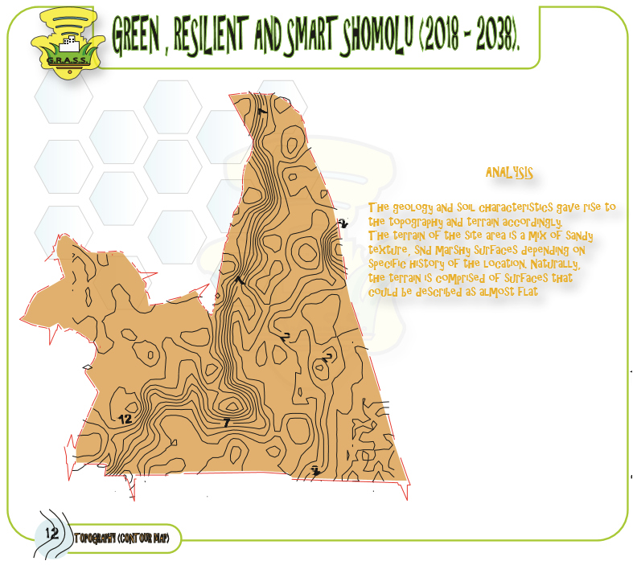

**Slope Analysis:**

A slope is the rise or fall of the land surface. Slope or gradient of a land describes both the direction and steepness of the land.

It is the ratio of the vertical height to the horizontal distance of a particular land area. It can be expressed mathematically as:

S = V.I * 100

H.D

Where S= slope

V.I= vertical interval

H. D= horizontal distance

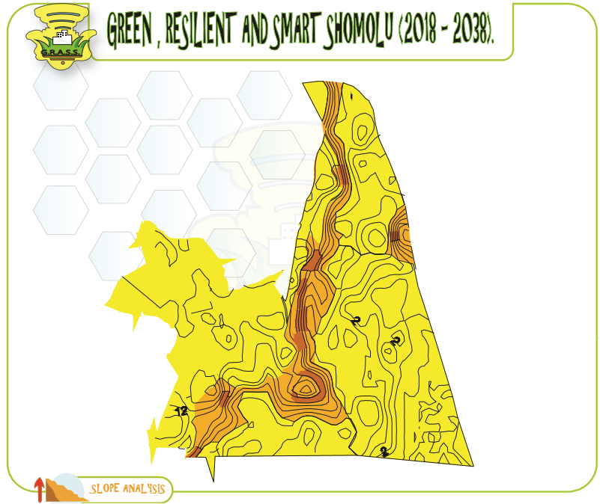

There are three variants of slope in the site given. They include:

* 0-5% flat land
* 5-10% gentle slope
* 10-15% moderate slope

A review of the slope or topography of the site shows that its gradient is between 5% and 7%. For example, the highest area is about 12 meters above the sea level. These are mostly the north eastern part. Other relatively high spots are in north central with levels between 7 meters and 10 meters. The gradient level of the slope is in the category of what could be classified as "with no constraints" in terms of its implication for development or construction work in the project area.

**Cross-section analysis:**

A cross-section shows the shape of a feature (such as mountain, plateau, or valley) viewed from the side as if cut through with a knife. There are four cross-sections in this map:

**Section A-A:** Section A-A cuts across the eastern stretch to the western stretch of the site.

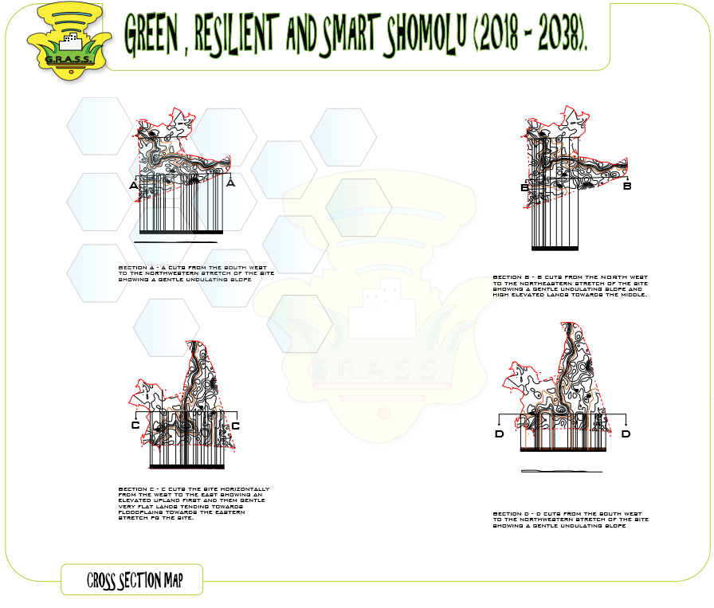

**Section B-B:** This section also cuts the site vertically from the Northern stretch to the Southern stretch of the site.

**Section C-C:** Section C-C on the other hand cuts across the site from the Northwestern stretch to the North-eastern stretch of the site.

**Section D-D:** Section D-D on the other hand cuts across the site from the Southwestern stretch to the south-eastern stretch of the site.

**HYDROLOGY**

This map shows the direction of flow of water. Water naturally flows from the highest to the lowest point as shown in this map.

Due to the configuration of the land, the direction of flow of the drainages in shomolu is towards the southeast down to the river. Even with this natural advantage, some drainage in the village are blocked and not flowing as a result of the dropping of wastes such as plastic bottles, polythene bags, water sachets, etc. into the drainages.

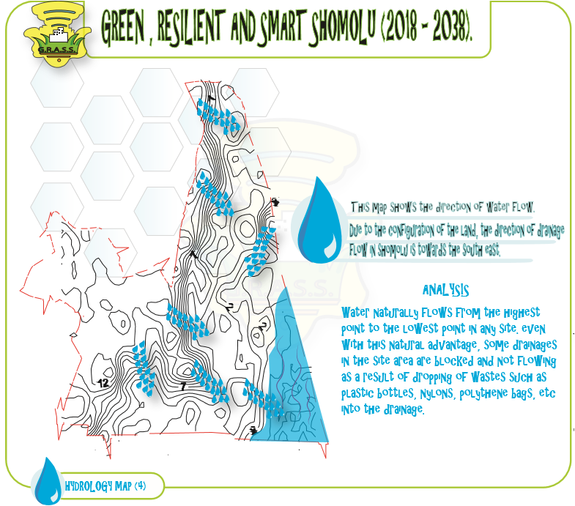

The design of drainage adopted in shomolu is the open drainage system with at least a meter depth. Some of these drainages are well paved and flowing as others are not paved.

**SWOT ANALYSIS AND DEVELOPMENT POTENTIAL**

Shomolu is blessed with abundant natural features that are yet untapped. These untapped natural resources can be a solution to the creation of the unavailable uses and add more socio-economic value to the site. The listed below are the natural features of Akoka:

* Wetland
* Lagoon
* Terrain

Unfortunately, for this particular area extending northward to areas like Ilaje, Bariga and Oworo are aesthetically poor despite the natural features found in these areas. These natural features, if well utilized it would add to the aesthetics and economic value of the communities.

However, due to the poor or lack of plan for these areas before it was developed, the natural reasons became a threat to the communities, for example the discharge of waste water directly into the Lagoon and the wetland causing the increase of mosquitoes and other infectious insects. The threats posed and opportunities that can be derived would be emphasized on.

**Wetland as a Natural Feature in Shomolu:**

Wetland is an area that is inundated or saturated by surface or groundwater at a frequency and duration sufficient to support, and that under normal circumstances do support, a prevalence of vegetation typically adapted for life in saturated soil conditions. Wetlands generally include swamps, marshes, bogs and similar areas. This wetland is located at the southern-eastern part of the site separating the community from University of Lagos.

**Opportunities of Wetland**

* **Erosion control.** Wetland vegetation reduces erosion along lakes and stream banks by reducing forces associated with wave action.
* **Fisheries habitat.** Many species of fish utilize wetland habitats for spawning, food sources, or protection.
* **Flood control.** Wetlands can slow runoff water, minimizing the frequency streams and rivers reach catastrophic flood levels.
* **Ground water recharge and discharge.** Some wetlands serve as a source of ground water recharge. By detaining surface waters that would otherwise quickly flow to distant lakes or rivers, the water can percolate into the ground and help ensure long-term supplies of quality ground water. Some wetlands are ground-water discharge areas; they receive ground water even during dry periods. This helps reduce the impact of short-term droughts on rivers and streams.
* **Natural filter.** By trapping and holding water, wetlands store nutrients and pollutants in the soil, allowing cleaner water to flow in to the body of water beyond or below the wetland. Vegetation, like cattails, can absorb some of the pollutants that remain in the soil. Wetlands also moderate water flows, providing time for sediments to settle out before the water is released to other wetlands, lakes, or streams. Less sediment means clearer waters and a better environment for aquatic life.
* **Recreation.** Wetlands are great places to canoe, hunt, fish, or explore and enjoy nature.
* **Source of income.** Wetlands provide economic commodities such as cranberries and fish and provide spatial amenities to developments.
* **Wildlife habitat.** Many animals depend on wetlands for homes and resting spots. Fish, amphibians, reptiles, aquatic insects and certain mammals need wetlands as a place for their young to be born and grow.
* **Education.** Wetlands provide ideal locations for classroom ecological studies and a focus for art.

**Threats of Wetland**

* Wetlands in the form of swamps are breeding grounds for mosquitoes and other diseases. Mosquito populations may be controlled partly in constructed wetlands.
* Wetlands have long been considered worthless and an impediment to development. They have been drained and filled to make way for houses, roads, and farmland.
* Constructed wetlands are unable to treat highly toxic modern wastewater. Such waste needs to be pretreated in special installations, which could impact on the visual beauty of a nature reserve. Residual pollutants may have a negative effect on the reserve's wildlife
* Methane has 10 times the atmospheric warming capacity of carbon dioxide and is the most effective greenhouse gas for global warming. Wetlands produce about one quarter of the Earth's atmospheric methane through the anaerobic decomposition of organic matter.
* Constructed wetlands are land-intensive undertakings. In the past, many countries had policies of draining and filling in natural wetlands to permit urban development. Levees, heightened river banks and sea walls provided flood defenses. Hurricane Katrina demonstrated the folly of such policies.
* Constructed wetlands are land-intensive undertakings. In the past, many countries had policies of draining and filling in natural wetlands to permit urban development. Levees, heightened river banks and sea walls provided flood defenses. Hurricane Katrina demonstrated the folly of such policies.

The importance of wetlands in this area Wetland helps to reduce the impacts from storm damage and flooding and also maintain good water quality in rivers, recharge groundwater, store carbon, help stabilize climatic conditions and control pests.

Lagoon**:**

Ilajeis one of the suburbs of Bariga local government area in Lagos State, It is bound to the North by Gbagada, to the South by Akoka, to the West by Bariga and to the East, the Ibrahim Babangida Bridge well known as 3rd Mainland Bridge. Starting from the northern part of Akoka (Ilaje road) down to the southern part (Moronfolu street) is bounded by the Lagos Lagoon the Eastern part.

The area can be accessed through the St Finbarr’s Road, it is accessible via Community Road and the Lagos lagoon by water and the community is very close to the coastline of Lagos. Due to location of the area close to the coastline, the lagoon as an advantage and also a disadvantage to the community.

**Opportunities of the Lagoon**

* Source of food: Water from the river is mainly used for washing, bathing and cooking and provides a steady supply of food to people since people consume fish.
* Provides fertile soil: The river provides fertile soil, thus make the land suitable for irrigation and also encourage settlement around it.
* Transport: The present of the river in the area is considered as an economic means of transporting goods as well as people moving from one place to another, and is beneficial when transporting bulky and heavy stuff. The best thing about river transport is that they don’t have to worry about traffic or whatsoever.
* Irrigation purposes: This is the act of transporting [water](http://benefitof.net/benefits-of-seltzer-water/)into large tracts of land for agricultural purposes, particularly in areas that face severe drought. Water from the river, is mainly used for agricultural purposes to ensure growth of crops.
* Generates electricity: Dams are usually built across rivers so that [water](http://benefitof.net/benefits-of-water/)can help in generating hydro-electric power, which is either used domestically or for industrial purposes.
* Great tourist attraction: The River magnificent views make great tourist attractions. In fact, almost all countries have river cruises that allow tourist to enjoy the sounds and sights of the vast land around them. In addition, this can help to create employment in form of tour guides and waiters in beach resorts. Some other advantages can also be for the purpose of Aesthetic (Beauty) and slightly lower temperatures.

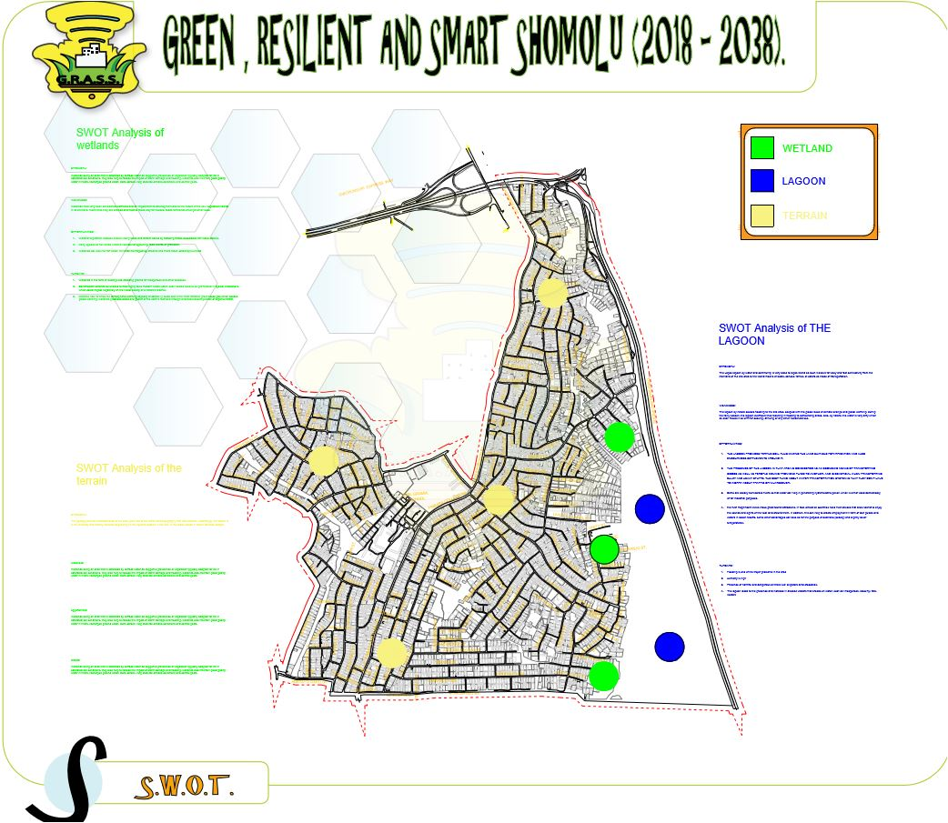

**Threats of the Lagoon**

* Flooding: the is one of the major problem of the area
* Increased humidity
* Increased disease vectors (mosquitos, rats)
* Pollution (industry, agriculture, golf courses major sources. Can't control what's upstream)
* Hazardous animals (alligators, crocodiles)
* Hampered land transportation (Bridges, Ferries)

**Terrain:**

The land is also a natural feature which can be an asset or a constraint depending on the degree of it steepness at different parts of the site. The runoff direction would also determine the possible opportunities and threats open to the site

**POPULATION PROJECTION AND DEMOGRAPHY ANALYSIS**

Population is defined as the total number of people living in a particular geographical area over period of time.

**DEMOGRAPHIC ANALYSIS**

Demographic studies are broadly defined as the scientific study of human populations. Major areas studied include broad population dynamics; fertility and family dynamics; health, aging and mortality; and human capital and labour market. It also refers to the study on size characteristics, distribution of human population and hence also be known as demographic data.

This is a form of analysing the certain populace that will fit in the proposed master plan with available and adequate resources, in this case population analysis share a broad light on the population of age structure and for certain reasons while various calculations are being made. For example, generally the low income earners are more populated than the high income earners in this case the population will consist more of low income earners, less middle income earners and few high income earners.

**SIGNIFICANCE OF POPULATION STUDIES IN PLANNING**

Population analysis is widely recognized as extremely important in urban and regional planning. A common feature o planning is that of relating requirements and needs to spatial distributions and designs. Population may be thought of as the key variable in a regional or urban plan, but it is insufficient to assume simply that population should first projected and then the plan should meet the population needs. The population projection should itself take into account likely future economic developments, and ideally should be done as the same time as economic planning. Planning decisions in respect of future distribution of people, economic and social activities as well as physical, aesthetic and resource considerations are vitally important, yet information is often relatively unavailable at a scale equal to that of the problem at which decisions are being made. The following listed below explains more on the importance of population studies in planning;

1. Population studies is important for projecting population during any physical planning activity
2. It also helps in spatial distribution while planning.
3. It helps in providing adequate facilities to the present and future population
4. It also helps to determine the various needs of different classes of people in a particular region
5. **Population studies is important for projecting during any physical planning activity:**

Basically, population projection is important while planning, in a case whereby tend to plan a neighbourhood of a population of 6000-8000 people. Population studies will help us to know if actually the chosen a population of the neighbourhood is 7000 people population studies will determine out of that population which of the age groups of classes of people will me dominant and or what specific reason could it be. A notable illustration is a case where by the outskirts of the neighbourhood is surrounded with concentration of commercial activities or industries such study of a population you’ll tend to have a working-class population or youth dominant or more out of the total population.

1. **It also helps in spatial distribution while planning:**

Population studies also helps in spatial distribution while planning in terms of allocating one land use to another considering the characteristics of the population. A notable illustration is a case whereby a population study whereby there are less working class people in a population and there are more o*f* unemployed youth in such a case there will be more provision *for* commercial activities and land uses as well as industrial land uses this as well helps in generating income into the economy thereby flourishing the economy.

1. **It helps in providing adequate facilities to the present and future population:**

Population study is important because when planning you tend to know the number of population you’re dealing with this helps in determining the number of facilities to provide for that population in avoidance of the facilities being unutilized or pressurized. Planners plan for sustainability; planners tend to forecast the future population the community might have, so in this case they tend to plan for the future population so as to avoid more pressure on available resources. A notable illustration is a case where a neighbourhood elementary school is to accommodate 1200 children and the population of that neighbourhood for children is 800 there is high tendency of having double of that same population in few years to come which will place more pressure on the elementary school. In this case population study has given the total population on ground planners will then forecast the future population in order to avoid pressures on available resources and facilities.

1. **It also helps to determine the various needs of different classes of people in a particular region:**

Population study is also important in planning because it helps to determine the various needs of people in a particular region. Classes of people in terms of age structure, sex structure etc., In a population study where there are more of children in this case provision of institutional facilities like schools, library and facilities like play grounds will be provided .Unlike a case where there are more of aged and retired people facilities like health centres where they can go or check-ups and petty commercial activities like trading centres where they get to engage in small scale businesses thereby sustaining themselves.

**DEMOGRAPHIC ANALYSIS FOR SHOMOLU**

It is a popular saying that population is not only about figures but more importantly its distribution across age and sexes.

The primary source for the demographic analysis was gotten from the Federal republic of Nigeria population and housing census of 2006 **Priority Table Volume IV.**

|  |  |  |  |  |
| --- | --- | --- | --- | --- |
| **Age Group** | **Male Population** | **Female Population** | **Total Population** | **Percentage** |
| **0-4** | 23,164 | 23,316 | 46,480 | **15.2** |
| **5-9** | 19,524  17,241 | 19,680 | 39,221 | **12.7** |
| **10-14** | 17,241 | 18,607 | 35,848 | **10.3** |
| **15-19** | 18,668  **2222222** | 19,489 | 38,157 | **9.1** |
| **20-24** | 26,039 | 24,957 | 50,996 | **9.8** |
| **25-29** | 26,829 | 24,707 | 51,536 | **10.2** |
| **30-34** | 20,236 | 17,099 | 37,425 | **8.3** |
| **35-39** | 15,684 | 12,915 | 28,599 | **7** |
| **40-44** | 11,151 | 9,577 | 20,728 | **5.3** |
| **45-49** | 8,922 | 7,255 | 16,177 | **4** |
| **50-54** | 6,266 | 6,057 | 12,323 | **2.8** |
| **55-59** | 4,616 | 3,756 | 8,372 | **1.7** |
| **60-64** | 3,372 | 2,900 | 6,272 | **1.3** |
| **65+** | 5,700 | 5735 | 11,435 | **2.3** |
| **Total** | 207,519 | 196,050 | 403,569 | **100%** |

Shomolu LGA Age and Sex Structure (**2006**)

There are various methods for projection population growth within a geographic area, these may include the simple linear projection method, exponential projection method, exponential projection method, Grey-Markov model (GM) among others. For this report and purpose, we would be implementing the Linear method of population projection. And the formula is expressed as:

**P**(t) **= P0 * (1 + r) n**

where;

**P**(t) **=** The population of the desired year

**P0** **=** The base population

**r =** The population growth rate (3.77%)

**n = T**he number of years you wish to project your population.

|  |  |  |  |  |
| --- | --- | --- | --- | --- |
| **Age Group** | **Male Population** | **Female Population** | **Total Population** | **Percentage** |
| **0-4** | 34,001 | 34224 | 68225 | **15.2** |
| **5-9** | 28683  17,241 | 28887 | 57570 | **12.7** |
| **10-14** | **25,307** | 27312 | 52619 | **10.3** |
| **15-19** | 27,401  **2222222** | 28606 | 56007 | **9.1** |
| **20-24** | 38,221 | 36633 | 57484 | **9.8** |
| **25-29** | 39,380 | 36266 | 75646 | **10.2** |
| **30-34** | 29835 | 25098 | 54933 | **8.3** |
| **35-39** | 23021 | 18957 | 41978 | **7** |
| **40-44** | 16367 | 14057 | 30424 | **5.3** |
| **45-49** | 13096 | 10649 | 23745 | **4** |
|  |  |  |  |  |
| **50-54** | 9197 | 8890 | 18087 | **2.8** |
| **55-59** | 6775 | 5513 | 12288 | **1.7** |
| **60-64** | 4949 | 4256 | 9205 | **1.3** |
| **65+** | 58366 | 8418 | 16784 | **2.3** |
| **Total** | 304606 | 287,771 | 592,377 | **100%** |

Shomolu LGA Age and Sex Structure (**2017**)

Shomolu LGA Age and Sex Structure (**2037**)

|  |  |  |  |  |
| --- | --- | --- | --- | --- |
| **Age Group** | **Male Population** | **Female Population** | **Total Population** | **Percentage** |
| **0-4** | 64460 | 64883 | 129343 | **15.2** |
| **5-9** | 54378  17,241 | 54765 | 109143 | **12.7** |
| **10-14** | **47977** | 51779 | 99756 | **10.3** |
| **15-19** | **51947** | 54232 | 106179 | **9.1** |
| **20-24** | 72460 | 69450 | 141910 | **9.8** |
| **25-29** | 74658 | 68754 | 143412 | **10.2** |
| **30-34** | 56562 | 47581 | 104143 | **8.3** |
| **35-39** | 43644 | 35939 | 79583 | **7** |
| **40-44** | 31029 | 26649 | 57678 | **5.3** |
| **45-49** | 24827 | 20188 | 45015 | **4** |
| **50-54** | 17436 | 16853 | 34289 | **2.8** |
| **55-59** | 12844 | 10451 | 23295 | **1.7** |
| **60-64** | 9382 | 8068 | 17450 | **1.3** |
| **65+** | 110652 | 15959 | 126611 | **2.3** |
| **Total** | 304,606 | 545,567 | 1,123,050 | **100%** |

From the base population as shown in the table above, Shomolu has a total population of 403,569 persons, it was then projected to have a present population of 592,377 persons after 12 years from 2006 till date. The proposed master plan for Shomolu will last from (2018-2038) and is expected to have a total population of 1,123,050 persons by the year 2038.

Shomolu is expected to grow rapidly in population and development, and these data can serve as the indispensable guide in the march towards sustainable development which is basically the driving force of this master plan. The essence of development is to make concrete improvement in the living conditions of the people. Since the people have different needs and potentials across sex and age divides, planning for development must therefore be gender sensitive and reflect the various needs of the different age groups in the society. This is the best way any development can be for all.

**3.6** **SAMPLE SIZE**

Sample size is subset drawn from the population which is the sample frame. The sample size finding would be used as the generalization for the total population in a research. With regards to the sample frame obtained, there is need to derive a sample size using a method which will ensure understanding the phenomenon properly without incurring too much expense, human labour and wasting too much time would be adopted.

Thus, this will be done by drawing sample size from the total population using Evan Morris Formula, 2007 which is selected in the determining the sample size needed for this research using this formula, this was also done in order to ensure at least 95% level of confidence and eliminate probable error and consideration of the alpha level which is level of acceptable risk in a way that true margin of error exceeds the acceptable margin of error.

* *n = Nz2Pq*

*e2 (N – 1) + Z2Pq*

where, *n* = the required sample size

*N* = finite population

*e* = the accuracy of your sample proportions level of significance (5%) 0.05

*1* = unity

*Pq* = are the population proportions (50%) 0.5

Z = (0.95)

Therefore, *n = Nz2Pq*

*e2 (N – 1) + Z2Pq*

Below is the calculation showing how the sample size was derived from the sample frame with the aid of ***EVANS MORRIS*** formula;

*n* = 631, 857 x (0.95)2 x (0.5)

(0.05)2 (631, 857 – 1) + (0.9025) (0.5)

*n* = 631, 857 x (0.9025)2 x (0.5)

0.025 (631, 856) + (0.45125)

*n* = 631, 857 x 0.4525

15796.4 + 0.45125

*n* = 285915.2925

15796.85123

*n* = 180.9955117

*n* = **181 approximately**

**PHYSICAL STRUCTURE**

Under the physical structure, we would be discussing the trends of communal and private lands, developed and undeveloped lands, this is to ascertain which lands are owned by the community, private individuals or government in the study area. A map would be produced to that effect.

We would also be discussing the physical structure of the site area in terms of present land uses as well as its analysis showing areas devoted to commercial land uses, residential land uses, industrial, administrative, recreational, public, mxed land uses as well as roads and streets. The future land use requirements and land values would not be left out.

Our slum clearance scheme would also be implemented and explained in this section using the process of spot clearance and redevelopments, explaining the scopes and limitations of the urban renewal plan.

The housing situation in shomolu LGA would also be analysed, discussing the existing housing stock, its quantitative and qualitative assessment, deficiencies, types of dwellings, size, occupation ratio, structural conditions, state of maintenance and repairs, types of construction, local building materials, architectural design, ownership. Rents and taxes, co-operatives and self-help housing, future housing needs.

**EXTENT OF COMMUNAL OR PRIVATE LANDS**

From the land use analysis carried out during site visitations, and from google earth, we were able to discover that majority of the lands In the study area are owned by private individuals. In fact, that is how it is Lagos state as a whole, more than half of the lands in the state are developed by either the community of private individuals, or even corporate bodies.

Narrowing down the scope to shomolu LGA which is the study area, virtually all residential lands and properties in the area are owned private individuals or cooperation, and it consists of about 75% percent of the total land use in the study area. based on the land use analysis carried out in the course of the master plan preparation. The remaining 25% are shared by commercial, industrial and public land uses.

The few government owned property in the study area includes:

1. The Bariga Police station
2. Lanre awolokun secondary school
3. Gbagada grammar school
4. Community motor park

Community owned properties in the study area includes:

1. CMS grammar school
2. The open field near Ilaje.

**EXISTING LAND USE ANALYSIS**

The dominant land use within the action area is residential, although it should be noted that within many residential properties, ancillary commercial activities also often take place.

Along St. Finbarr’s road, the land use is more varied with a wide mix of residential, commercial, educational, health and governmental land. This wide variety is to a large part a consequence of the efficiencies and adaptability of the regular grid structure of the area.

Within the olanrewaju road area, the dominant land use activity is industrial, with the area housing a number of spare parts warehouse and auto-painting industries. Additionally, a variety of associated commercial enterprises have developed on the back of the auto-painting industry, i.e. furniture making, retail shops, etc. Ancillary residential land uses can also be found in the area.

The Ilaje slum is dominated by residential land uses, although it is recognized that there are significant ancillary commercial activities also taking place within the area. The Ilaje slum is well known for its smoked fish industry, and as a consequence the area is often shrouded in wood smoke from these activities. A range of public facilities such as schools, religious buildings and health centers, which serve the population of the slum area, have developed along the original waterfront. The recent construction of floating health and education facilities over the lagoon, represent the latest efforts by the State Government, to address the deficiencies of service provision across the area.

**Existing building condition:**

Building conditions reflect the character of different sections of the action area. Shomolu has a complex mixture of all types of building conditions from good to dilapidated which varies sometimes on a plot by plot basis, with buildings of a good condition found beside those in a dilapidated condition.

Ilaje and Bariga, by comparison, are dominated by buildings in poor and dilapidated conditions, reflecting the slum and heavy residential nature of the areas.

**Existing building material:**

As with building height and condition, the dominant building materials reflect the character of different sections of the action area. The buildings in shomolu are generally constructed in solid masonry, cement block/ concrete, with a small number of brick built structure.

In contrast, development in the Ilaje slums and at Bariga, are for the most part constructed out of timber/ bamboo. In particular, development over the lagoon, such as can be seen in Makoko has to be constructed in a light weight material like timber. With piecemeal land reclamations often being undertaken by individual property owners, more solidly constructed buildings are likely to be seen in the future in these areas.

**STRUCTURE OF THE CENTRAL AREAS OF THE TOWN, ITS PROBLEMS AND POTENTIALS**

The central area in shomolu 1 sub-division of shomolu LGA is around Bariga market, at the northern stretch of the site towards the Oworonshoki interchange. Bariga which is fast becoming a transport node in Lagos state linking places like oshodi, mushin, onipan, berger, et cetera. Also houses a market which attracts people from various settings and backgrounds.

**PROBLEMS OF THE CENTRAL AREA**

Although there are traffic management officials on the roads linking the market from st finbarrs road to the market and then to the Oworonshoki interchange. A few of the problem usually experienced by commuters along the traffic routes include:

1. Vehicular congestion
2. Pollution; land, noise, and air
3. People selling on the roads
4. Poor road conditions

**POTENTIALS OF THE CENTRAL AREA**

1. It fosters economic activities
2. It serves as a source of attraction to the study area
3. It serves as a source of employment for the masses

**SLUM CLEARANCE; SCOPE AND LIMITATIONS**

It is not easy to find a satisfactory definition of urban renewal which embodies the complexity of issues involved in the process. Some of the existing theoretical and ideological disagreements about urban change are thought to come, in part, from the fact that the terms used by different scholars reflect different perceptions of the phenomenon and its significance (Palen and London 1984). Urban literature uses, often

without definition, terms such as urban regeneration, urban revitalization, gentrification, neighbourhood renewal, rehabilitation, and renovation. In this discussion, the term urban renewal is used to refer to the general process of transforming the urban environment.

Urban renewal is often presented as a natural process through which the urban environment, viewed as a living entity, undergoes transformation. “As the years pass, transformations take place, allowing the city to constantly rejuvenate itself in a natural and organic way” (Treister, 1987: 57).

A “people-centered” approach should be used to carry out urban renewal. The purpose of urban renewal is to improve the quality of life of residents in the urban areas. The Government has to balance the interests and needs of all sectors of the community without sacrificing the lawful rights of any particular group. Urban renewal is not a “slash and burn” process. A comprehensive and holistic approach should be adopted to rejuvenate older urban areas by way of redevelopment, rehabilitation and heritage preservation.

**The Objectives of Urban Renewal**

The main objectives of urban renewal are as follows:

* Restructuring and re-planning of concerned urban areas.
* Rationalizing land uses within those urban areas.
* Designing more effective and environmentally-friendly local transport and road networks within the concerned urban areas.
* Redeveloping dilapidated buildings into new buildings of modern standard and environmentally-friendly design.
* Promoting sustainable development in the urban areas.
* Promoting the timely maintenance and rehabilitation of buildings in need of repair.
* Preserving buildings, sites and structures of historical, cultural or architectural value.
* Preserving as far as practicable local characteristics.
* Preserving as far as practicable the social networks of the local community.
* Providing purpose-built housing for groups with special needs, such as the elderly and the disabled.
* Providing more open space and community/welfare facilities.
* Enhancing the townscape with attractive landscape and urban design.

**The Purpose or Goal of Urban Renewal**

The purpose or goal of urban renewal is to improve specific areas of a city that are poorly developed or underdeveloped. These areas can have old deteriorated buildings and bad streets and utilities or the areas can lack streets and utilities altogether. For a municipality to use urban renewal, it must establish an urban renewal agency and it must adopt an urban renewal plan. Also to address the problem of urban blight and to improve the living conditions of residents in blighted communities.

The goal or purpose of urban renewal are as follows:

* Obtaining a better living environment that includes:
* Safe and secure
* Higher Quality
* More Greenery
* Energy, Efficient, Sustainable
* Better Architectural Features.
* More functional properties
* Increase in value of properties
* Wholesome approach
* Reduce poverty, unemployment and crime in such areas.

**Urban Renewal Strategies and Approaches**

The urban renewal strategy is meant to guide the growth of the slum communities in the urban areas. The Urban Renewal Strategies is a Nigerian government strategy to be implemented by the urban renewal agencies as well as relevant non- governmental departments and other stakeholders. Urban renewal strategy is planning effort to revitalize urban slum with huge and increased population. Every year, many Nigerians migrate to urban centres, the consequences of this trend result to overuse limited facilities and decay necessitating renewal. Slum is a regular feature of today urban centres. Lagos state is a typical model where decay of urban centre exists. One factor that influences the prevalence of slum is poverty.

Urban renewal strategy also spells out the principles, objectives of urban renewal, and the target, the role of renewal agency, the processing of projects, land assembly process,

financial arrangement, the social impact assessment. In addressing the problem of urban decay, workable strategy for urban renewal should not be “slash and burn” process instead a comprehensive and holistic approach should be adopted to rejuvenate older government strategy. Moreover, the objectives of the initiative must include harnessing the potential of towns and cities as engines of social and economic growth and development; creating orderliness and ensuring that components of the towns and cities function efficiently; as well as improve the aesthetics of the towns and cities to promote healthy living, promote tourism and enhance the urban economy.

The core concept of urban renewal strategy is uplifting the physical, economic social status of urban centres through the application of 4R business strategy or Principles: Redevelopment, Rehabilitation, Revitalization and heritage preservation. There is the need to understand the social elements and the social impact of the strategy by conducting a balance assessment before publishing and Gazette. Assessments should cover knowledge of the population characteristics of the proposed project area; the socio-economic characteristics of the area; the housing conditions in the area; the characteristics of local business activities including small shops and street stalls; the degree of overcrowding in the area; the availability of amenities, community and welfare facilities in the area; the historical background of the area and the cultural and local characteristics of the area. Urban renewal is rewarding but challenging.

Blighted areas are demolished and reconstructed and thus transformed the physical landscape for good. Nevertheless, during redevelopment, residents are displaced and may be under compensated and some tenants and businesses are disrupted the achievement of urban renewal is highlighted by Law C.K (2010). He wrote that the strategy of urban renewal rejuvenates, revitalized neighbourhood conditions, turning it around entirely. However, the challenges are enormous largely due lack of understanding between government and the other stake holder. When government decides to re-develop, the affected public is largely outside the policy framework of governance, and hardly are they informed on time. The reason is not far fetch. Jimoh. et al. (2013) said that when action has been taken it is always ad-hoc, policies not properly defined.

“Over the past five decades, authorities in African countries have adopted several strategies to take the problem of slums and informal settlements. These approaches include benign neglect; repressive options such as forced eviction and demolition; resettlement or relocation, slum upgrading programs and most recently the adoption of enabling strategies.”

Urban renewal approaches may include:

* Redevelopment
* Rehabilitation
* Upgrading
* Revitalization
* Preservation
* Participatory slum improvement
* Spot clearance

**Slum Upgrading**

In its most basic form, involves improvements in the physical environment of the existing area. Example of what this might involve include improving or installing basic infrastructures services such as water, sanitation, solid waste collection, electricity, storm water drainage, access roads, footpaths and street lighting. Interventions may also include home improvements and securing land tenure and also interventions related to services (such as health and education) and livelihoods. The purpose of most slum upgrading strategies is to improve the health and quality of life for residents of slums.

**Total Redevelopment**

The challenges of total redevelopment are as follows:

* Health implication
* The process is capital intensive/lack of adequate financial support.
* High cost of redevelopment
* Loss of heritage
* Loss of social network
* Selfish government interest
* Loss of socio-economic attachments
* Psychological effect

Ways to combat the challenges of total redevelopment.

* Create a relocation plan and strategy
* Phase the development of total redevelopment.

**Participatory Slum Upgrading**

This approach was developed by UN Habitat in 2008, after been discomforted by the different “uncool” approach and to improve the living conditions in town and cities and contribute to the Millennium Development Goal (environmental sustainability) Target 7. It involves people in the process of upgrading from the beginning of the scheme to the end. It also changes the process of the top-bottom approach to “bottom-up approach”.

To make this participatory slum improvement/upgrading operational, it is divided into three (3) phases:

* Urban Profiling
* Action Plan
* Project Implementation

**EXISTING WATER SUPPLY SYSTEMS**

A water supply master plan has to be prepared for Somolu Local government area. This report covers the existing situation of water supply system in Somolu LGA with reference to the previous projects/studies and the data collected from the site visits.

**PREVIOUS STUDIES**

1. Master plan for metropolitan Lagos (volume II): Short range (1985) and long range (2000) development programs – 1978
2. Lagos Water Supply Management: Initiatives for improvement of financial management and service level – 1996
3. Water consumption in Lagos – 2000
4. Proposed Lagos Metropolitan Development Project (LMDP): Draft technical proposal for upgrading 9 blighted areas in Lagos – 2002
5. Urbanization and Water: The stages of development in Latin America, South-East Asia and West Africa – 2002
6. A case study of the Lagos State Water corporation (LSWC) – 2003
7. Water and Electricity in Nigeria – 2006
8. Population census for Nigeria – 2006
9. First multi-state water supply project: Nigeria – 2007
10. Private Sector Participation in Water Supply: Prospects and Challenges in developing economics – 2007
11. Feasibility study for a raw water sources on Oshun River with associated potable water treatment and distribution facilities (planning report for system facilities volume-2, final report)

**DESIGN PARAMETERS AS ADOPTED IN PREVIOUS STUDIES/SUGGESTED MODIFICATIONS**

Due to unavailability of design parameters adopted for water supply system at Lagos central, the following design parameters are suggested for the proposed master plan:

**Water Consumption**:

The water consumption rates shall be based on the nature of development, population density, living standards; climate of the city etc. The table below illustrates the recommended water consumption rates based on the above factors.

**Storage Requirements:**

A one-day storage is normally considered as a desirable minimum to safeguard against the possibility of breakage in the transmission main and/or interruption in supply from the water source. It is also useful to cater for the variation between the peak water consumption rate in a day and the average daily supply from the source.

**Design Peak Factors:**

Water use rate is affected by climatic conditions. The highest daily water demand normally occurs during the hot season. Peak demands also occur during the day; the hours of occurrence depend upon the characteristics of the project and the user’s habits. Thus, the total amount of water used may be distributed over only a few hours of the day, during which the actual demand is much greater than the average. In order to respond to these various demands, the average water demand is multiplied by peak factors.

The design peak factors normally related to the water supply system are Peak Daily Demand (PDD) and Peak Hourly Demand (PHD). The PDD shall be adopted since the PHD is not applicable because the hourly variation in demand shall be mitigated by the storage to be provided in each dwelling or building as per the current practice in Lagos. The following peak factors are recommended:

Peak daily demand = 1.2 times the average daily demand

Peak hourly demand = 1.8 times the average daily demand

**Pipe Material**:

The parameters considered for selecting suitable pipe material are capital cost of material, construction cost, corrosion resistance, structural strength, expected service life, environmental conditions, maintenance and available pipe sizes. The following materials are generally used for water supply systems:

* For pipe diameters larger than 300 mm: Ductile Iron (D.I.), G.R.P., uPVC or Prestressed Concrete Cylinder Pipes (P.C.C.P.).
* For pipe diameters ranging from 80 mm to 300 mm: D.I., and uPVC.
* For pipe diameters less than 80 mm: Polyethylene (PE), uPVC and Galvanized Mild Steel (G.M.S.).

It is recommended to use following materials for Lagos Central water supply system:

* uPVC for pipe diameters less than or equal to 300 mm
* Ductile Iron (D.I.) for pipes greater than 300 mm

**Velocity:**

The maximum allowable velocity in the water supply lines shall not exceed 2.5 m/s to limit friction loss and optimize pumping and/or elevated water tank height requirements.

**Distribution Networks:**

The hydraulic analysis and conceptual design of the network will be carried out using known water network simulation software. The Hazen Williams coefficient is considered as 150 for uPVC and PE pipes, 130 for new Ductile Iron (D.I) pipes or any equivalent coefficient for other method to be used. The distribution mains shall be sized to deliver water with a minimum residual pressure of 15.0 m. The design of distribution mains shall ensure that the average water supply demand plus the firefighting demand can be delivered at a minimum residual pressure of 15.0 m (20 psi). The fire hydrants shall be installed on pipe diameters greater than 150 mm.

**EXISTING SITUATION:**

The project area is shomolu LGA, the population of this study area, as well as the land use analysis are well elaborated in the tables below.

**Water Resources and Production:**

Lagos State Water Corporation’s (LSWC’s) water resources consist of both surface water and groundwater. The main surface water source is presently the Ogun River. The safe yield is about 520MLD. Raw water from the Ogun River is abstracted at Akute and pumped to Iju waterworks (constructed in 1915) and Adiyan (constructed in 1991) for treatment with a designed capacity of 45MGD and 70MGD respectively. The waterworks are about 25km from Shomolu LGA. The existing water treatment plants and mini water works in and around the project area are shown in the table below. The existing pumping stations have capacities 12MGD each (5 working + 4 standby) at Iju intake and 24MGD each (3 working + 2 standby) at Adiyan intake. Iju waterworks has pumping stations of 7.5MGD each (8 working + 4 standby) and Adiyan waterworks has pumping stations of 18MGD each (4 working + 3 standby) respectively.

The mini water works in Shomolu with conveyed water from boreholes (total capacity of 35.1MLD) were constructed to feed directly into the existing networks. The table below shows the existing water works in the study area.

The demand of water in Lagos is much bigger than the supply. Many people use too small amount of water because they either do not have access to water or they have to carry it from far away. The water demand for Lagos city by 2010 is expected to be 1821 MLD.1 But, in the city, only 216 MLD of treated water is available. In total, the LSWC’s water production capacity is about 555.1MLD but the problem of power supply (6 hours/day) is a major constraint to two major water treatment plants. The table below shows the plant capacities and efficiencies in Shomolu LGA.

It is reported that only about 85% of households in Lagos have access to safe water. In Lagos 69% of population use piped water, 16% wells, 9% bore holes, 6% streams, ponds etc. It is noted that the distance to water source in Lagos is for 11% of the population more than one kilometre.2 The construction of water works have, however, enabled many areas to have adequate water, but generally, private wells, commercial water tankers, individual bore well continue to be the source of water for over 50% of the population in the urban areas and 70% in the rural areas.

**Water Quality and Treatment:**

The raw water of Ogun River is highly turbid, less acidic, and very rich in oxygen. Treatment of surface water follows a conventional process of sedimentation, coagulation/flocculation, and rapid sand filtration at each of water treatment plants (WTPs). Water is chlorinated, both pre- and post-treatment, at all treatment facilities. With reference to pollution studies on water bodies namely Isolo canal, Lagos Lagoon and the seaport in Lagos area, the study shows that small concentrations of Cr, Co, Ni, Ag and Pb were found in the water samples. This may be attributed to different anthropogenic inputs from industrial and sewage effluents.

In piped water, Escherishia coli, Salmonella, Streptococcus and Bacillus are normal contaminants. This indicates faecal pollution of human and animal origin. This impurity leads to diarrhea, guinea worm, cholera and typhoid

In general, Lagosian people do not boil the water they drink; they either buy pure water from vendors or clear the water with alum. The visible clarity is more important to Lagosian than microbiological clearance. Filters are not often used.4 Due to lack of availability of safe drinking water, the sealed polythene packaged water otherwise called “Pure water” began over ten years ago in order to provide safe drinking water to the public. This drinking water will not always be absolutely pure, but samples tested were in general acceptable. Overall the water samples met reasonable and acceptable physio-chemical requirements for drinking water.

**Water Transmission, Storage and Distribution:**

The Lagos State Water Corporation (LSWC) operates in 28 zones covering 3,577 sq. km and incorporating a population of 12.4 million. The project area is covered by Shomolu LGA.

The LSWC distributes water through 116.7km of core primary mains and a further 48.3km of non-core primary mains with diameter ranging from 100 mm to 1600 mm. The pipe material of existing primary mains is cast iron (older mains), mild steel and Polyvinyl chloride (PVC).

Adiyan waterworks (capacity 70 MGD) with its water source at river Ogun was commissioned in 1991. It supplies water through a primary trunk main from 800mm to 1200mm with 88.4km of total length. Storage capacities at the various reservoir sites range from 5,000 to 50,000m3. The Adiyan water works has two clear water storage reservoirs at Oke and Aro, each with capacity of 50,000m3. The clear water is supplied to Lagos Metropolis by gravity from the reservoirs.

On the other hand, Iju waterworks with a capacity of 45 MGD supplies water to treated water reservoir of 8,000 m3 and service reservoir of 24,000 m3. The detail of transmission mains from iju waterworks is given in Table 7.1.6 below. From these tanks, treated water is pumped to the public through overhead tank at Ishaga of 5,000 m3 capacity.

|  |  |
| --- | --- |
| Local Govt Area (LGA) | Population (2017) |
| Shomolu | 592, 377 |

**Operation and Maintenance:**

Inadequate maintenance of water infrastructure has been responsible for the reduction in the production capacity of water supply system to much below the design capacity (efficiency of less than 30% in some cases). Frequent power cuts reduce the pumping period which is an important factor in the deficiency of water supply, sometimes up to 20% to 30% of the design capacity. Another important factor affecting the efficiency of the system is the leakage losses. Of the residents of Lagos, 10% associates burst pipes with water outage; 84% claims that burst pipes are often left unattended for long periods. The leak detection survey is being carried out for 15% of greater Lagos area and 17% of the area is under a preventative maintenance programme. The low level of funding is a primary cause of the low level of water service.

**Metering and Customer Connections:**

According to the company, until 1997, water was provided free of charge in Nigeria, with direct subsidies from the government. The revenue collection is very poor in Lagos, which is about 4% of water produced (in 2001). Also, the exact area served by the distribution system are not known due to a lack of record drawings

**EXISTING DRAINAGE SYSTEMS**

**Previous Studies/ Projects:**

The following previous studies and projects related to storm water drainage were undertaken in and around Lagos Central, which shall be useful in the formulation of this project:

1. Storm water Drainage for Mainland Lagos Storm Water Drainage Study for Lagos Island
2. Lagos Drainage & Sanitation Project Drainage Development plan for Greater Lagos and Drainage Investment Program
3. Detail Engineering Apapa Storm water drainage Study
4. Land Use and Infrastructure Master Plan an overall plan showing the drainage projects taken up in Lagos and around the project area

**Design parameters as adopted in previous studies/ suggested modifications:**

The design parameters and assumptions used in the 1974 drainage master plan for Mainland Lagos and 1998 master plan for Greater Lagos are revaluated and relevant modifications are suggested in case of certain deviation. The design parameters include rainfall analysis, runoff estimation method, runoff coefficients, design frequency, roughness coefficient, velocity limitations and free board. These design parameters have been compiled and evaluated before we chose to adopt them for use in Shomolu LGA. The design parameters adopted in the earlier master plans and suggested modifications are as follows:

**Return Period**

The return period or frequency of rainfall occurrence used for design determines the degree of protection afforded and the amount of damage prevented by a given storm water drainage system. The following rainfall frequencies were adopted for the design of drainage systems in the 1974 Master Plan:

a) For storm channels in low and medium density residential areas – 2 years

b) For storm channels in high density residential and low cost commercial areas – 5 years

c) For storm channels high cost commercial and industrial areas – 10 years

d) For major structures such as bridges and culverts – 10 years

In the 1998 Masterplan the return periods were revised as: 5 years for drainage channels, 10 years for culverts and 25 years for bridges.

**Suggested Modifications:**

Storm frequencies shall be modified as follows:

a) For internal drainage channels – 5 years

b) For main drainage channels – 10 years

c) For culverts – 25 years

d) For bridges – 50 years

**Rainfall Intensity –Duration – Frequency (IDF) Relations:**

The IDF curves are the basic design criteria affecting the sizing of the system. During the preparation of 1974 Master Plan, two meteorological stations at Ikeja and Lagos falling within the project area provided the basic data used for developing the IDF curves. Furthermore, field investigations revealed the existence of a number of curves prepared from rainfall data taken from the Ikeja and Lagos stations. These curves were obtained from various sources:

1. Federal Ministry of Works: These curves are based on rainfall data covering the period between 1938 and 1944
2. Gilberts and Associate master plan report: These are based on rainfall data covering the period between 1948 and 1964.
3. Federal Meteorological Services: The period these curves cover is not given.
4. A tabular analysis form of rainfall intensity-duration-frequency of Lagos and Ikeja..

The curves obtained from various sources were plotted and compared and thus synthesized as a curve for each station. These curves were then evaluated in the light of the available daily data covering the period 1943- 1972, and have proved to be realistic.

Suggested Modifications:

Recently, the draft Land Use Infrastructure master plan was prepared for Lekki Free Trade Zone, Lagos. The IDF curves were revaluated using the latest drainage Master plan in Lagos State was prepared for Greater Lagos in 1999. This Masterplan analysed rainfall information for four stations (Ikeja, Lagos, Ebutte Metta and Apapa) for the period 1925 – 1996. Analysis was based on short duration rainfall events done for Lagos Drainage Master Plan (1974). It was found that rainfall values at Lagos station are more applicable to this area. The Consultants have collected additional up-to-date rainfall data including the following: Daily rainfall for four stations in Lagos (Lagos Marine, OshodiAgro, Lagos Roof, and Ikeja) for years 2003-2006 Updated rainfall Intensity-Duration-Frequency curves for Lagos Area (Ikeja, Lagos Headquarter, Epe, Badagry, Apapa, etc.) established for the period 1970-2002

To develop an Intensity – Duration – Frequency (IDF), it is required to obtain short duration rainfall data for all rainfall durations or to use 24-hr rainfall data along with ratios of shorter duration periods relative to the 24-hr depth. The later procedure is adopted for developing the project IDF. The 24-hr data is available from ground station, covering 56 years. Performing frequency analysis using the Gumbel distribution gives the results as shown in Table below

Frequency Analysis results for the rainfall for Lagos ground station.

|  |  |  |  |
| --- | --- | --- | --- |
| **Return Period** | **24-hr rainfall depth** | **Standard deviation** | **Confidence Interval (95%)** |
| 100 | 288 | 26 | 339 |
| 50 | 261 | 22.3 | 205 |
| 25 | 234 | 18.7 | 270 |
| 20 | 225 | 17.5 | 259 |
| 10 | 197 | 13.8 | 224 |
| 5 | 168 | 10.3 | 188 |
| 3 | 145 | 7.74 | 160 |
| 2 | 124 | 6.09 | 136 |

**Existing Situation:**

The project area for which protection from storm water flooding is envisaged consists of urban, suburban, wooded and swampy lands. The area is severely affected by storm water flooding. The factors contributing to localised /drainage problems are:

1. **Natural Causes:**

* High Rainfall Intensity
* Flat topography
* Tidal Water
* Poor Infiltration

1. **Man- Made Causes:**
2. Non provision or inadequate provision of tertiary collector system for storm water, lack of maintenance of the systems, including blockage of rights of way and channel space.
3. Unplanned and uncontrolled development modifying natural drainage patterns or overloading local systems.

**Topography:**

The project area is generally flat, and ground levels vary from sea level to about 46metre above sea level. The flatness of the area retards the flow of surface runoffs and prevents its rapid discharge into the sea. Consequently, the water accumulates in the project area creating local swamps, raising ground water table and causing temporary flooding conditions.

**Ground Water Table:**

The ground water table is high in most of the project area. The water table is as high as 60cm from ground surface in areas along the shores of the Lagos Lagoon.

**Poor Infiltration Conditions:**

Due to the colloidal nature of soil, poor infiltration conditions prevail in the project area, only a small percentage of rainfall water seeps into the ground in the developed areas, whereas the largest percentage of rainfall flows overland in to the swamps of undeveloped areas.

**Street Condition:**

Most of the streets in the project area are not properly graded to efficiently receive and discharge the rainwater flows. In many instances the point where a number of streets intersect is the low point of these streets. With no proper water inlet points provided, flooding occurs at such points. Many streets are provided with no curbs and water is allowed to flow over unpaved shoulders to reach storm water channels. The shoulders are often cluttered with garbage, refuse and other natural debris, which obstruct the rapid flow of water causing its backup on street.

**Growth Explosion:**

The project area has experienced a fast and dramatic growth, which has direct as well as indirect effects on flooding problem. The growth has taken place rapidly without any proper planning and proper provision of storm water drainage facilities, which has aggravated the drainage problem as the urban area has expanded, thus producing higher amounts of runoff. The lack of proper planning and zoning within Metropolitan Lagos has encouraged the rapid and haphazard construction of shacks and slums directly in the way of natural water courses. These obstruct the flow and create local flooding conditions.

**Operation and Maintenance:**

The lack of sufficient personnel and proper equipment has further hampered the operation and maintenance of storm water drains which have become plugged and damaged. The lack of mechanized cleaning equipment has resulted in delays in repairing damaged or plugged drains. This has made worse the existing scenario of storm water drainage.

**OTHER SYSTEMS**

**Electricity System**

Electricity is the set of physical phenomena associated with the presence and motion of electric charge. Although initially considered a phenomenon separate from magnetism, since the development of Maxwell's equations, both are recognized as part of a single phenomenon: electromagnetism.

Electricity is at the heart of many modern technologies, it is being used for:

* Electric power where electric current is used to energize equipment
* Electronics which deals with electrical circuits that involve active electrical components such as vacuum tubes, transistors, diodes and integrated circuits and associated passive interconnection technologies.

The electric power sector is one of the most important sectors to national development. The power sector is critical to the developmental reform of any country. Electricity supply in Nigeria dates back to 1886 when two small generating sets were installed to serve the then Colony of Lagos. By an Act of Parliament in 1951, the Electricity Corporation of Nigeria (ECN) was established and in 1962, the Niger Dams Authority (NDA) was also established for the development of Hydro Electric Power. However, a merger of the two was made in 1972 to form the National Electric Power Authority (NEPA), which as a result of unbundling and the power reform process, was renamed Power Holding Company of Nigeria (PHCN) in 2005.

The electricity facilities in Somolu local government area are functional though they can be replaced or repaired for better efficiency. The power plants along Ikorodu road just after Igbobi orthopaedic hospital and before Consolidated hospital Ilupeju are the major government electricity facility in Somolu local government area now owned by Ikeja Electric Distribution Company.

**Postal Agency**

This is a customer service facility forming part of a national postal system. Post offices offer mail-related services such as acceptance of letters and parcels; provision of post office boxes; and sale of postage stamps, packaging and stationery.

There are two postal agencies in Somolu local government area. One along Shipeolu str. And the other at Shogbamu str. Bariga.

**Telegraph and telephone system**

A telephone is a telecommunications device that permits two or more users to conduct a conversation when they are too far apart to be heard directly. A telephone converts sound, typically and most efficiently the human voice, into electronic signals that are transmitted via cables and other communication channels to another telephone which reproduces the sound to the receiving user. There are a number of telephone system facilities in Somolu local government area including masts and satellite dishes..

**Street Lighting**

This is a raised source of light on the edge of a road or path, modern lamps now have light-sensitive photocells that activate automatically when light is or is not needed: dusk, dawn, or on the onset of dark weather. In some parts of Somolu local government there are street lights mostly around the commercial area and along major access routes and they are functional though they cannot be said to be light sensitive.

**Fire Fighting**

Fire station (also called a fire house, fire hall, or firemen's hall) is a structure or other area set aside for storage of firefighting apparatus such as fire engines and related vehicles, personal protective equipment, fire hoses and other specialized equipment. It may also have dormitory living facilities and work areas for the use of fire fighters. Living areas are sometimes arranged above the garage boys where personnel without specific station duties during the night shift are allowed to sleep unless a dispatch is called. In that situation, the fire fighters may have special means to allow entry to the groung floor quickly when a call for help is received, such as sliding down a brass pole called a fireman's pole. this arrangement allows for a raised area to hang hoses to dry to prevent damage. in a single story situation, a tower like structure is sometimes used for hose hanging. With the above it is essential that they are sited at every 800m to aid accessibility and reduce damages after occurrence. After site visitation and administration of questionnaire it was observed and reported that there are no firefighting stations in Somolu local government area as observed.

**CONCEPTUALZATION**

With respect to the aims and objectives the following concepts are to be used in the development of Somolu LGA.

**CONCEPT A** (**Grass city Concept**)

Creating a Green, Resilient and Smart Somolu leading to a reduction of land surface temperature, eco techno environment and promote effective land use organization amongst all level. This concept incorporates the following:

1. Sustainable residential district with state of the art of infrastructure, with priority to green environment.

2. New generation pro and sub-techno hubs in parks, open, public places.

3. Multi-modal and semi-motorized movement within towns with concentration on transit,

pedestrian and cyclist activities with the existence of Ikorodu, 3rd mainland and Oworoshoki highway.

4. To develop a high grade technology area.

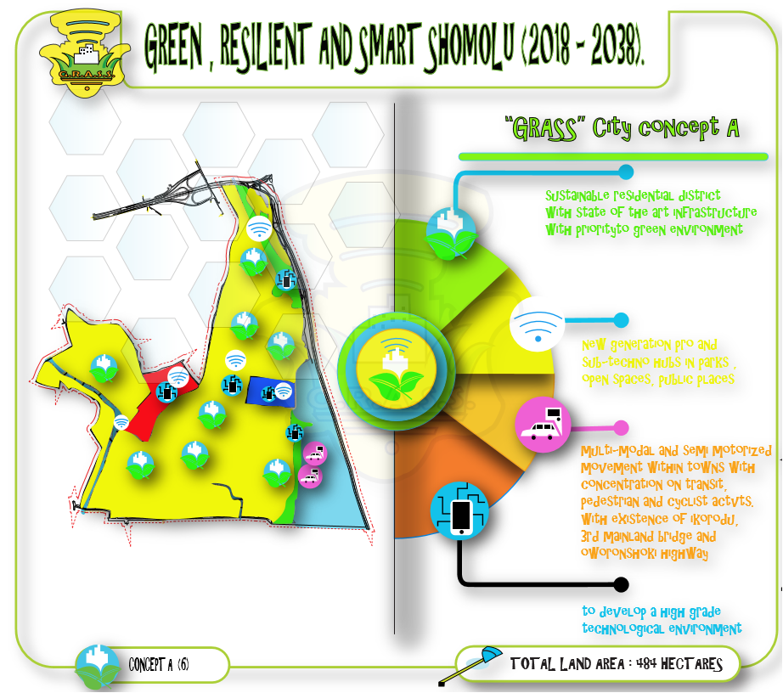

**CONCEPT B** (**Economic sector Concept**)

This concept is aimed at improving commercial and industrial uses and facilities in other to enhance financial sustainability.

1. High grade commercial hubs with sales and services-oriented framework

2. Resilient light and high-tech industrial strata

3. Self-sustaining residential district with consideration for infrastructure and technology

4. Consideration for positive economic framework to boost interdependence and

independence. (Skill training)

1. Exploitation of the water resources to create an alternative source of electricity to service industrial and commercial activities.

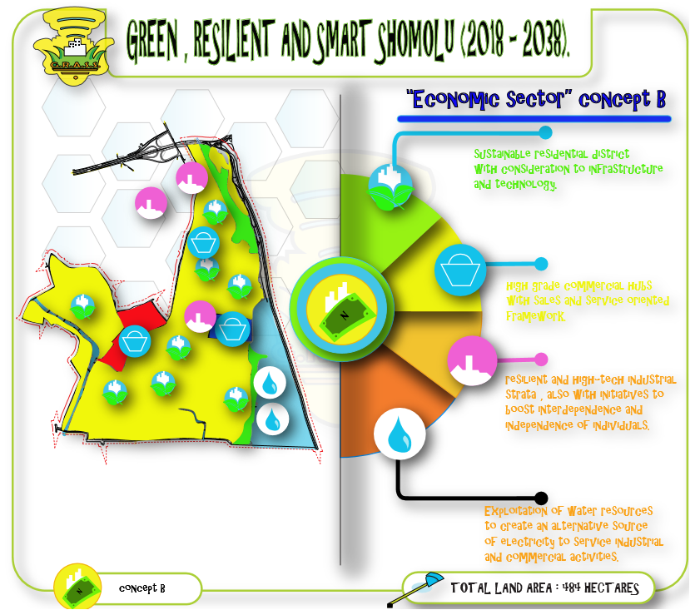

Prior to the concepts explained above the planning team is expected to:

1. Procure Base map of the Planning Area;
2. Carry out baseline study on land use, natural resources, the economy, social elements, as well as infrastructure of shomolu LGA;
3. Undertake data analysis, review and evaluation;
4. Hold stakeholders consultative / engagement meetings;
5. Generate Conceptual Plans and Alternative Plans of the Planning Area over a period of 20 years;
6. Review plans with stakeholders to evolve Final Physical Development Plans; and
7. Articulate and prioritize basic service and infrastructure development projects for the Planning Area in conjunction with stakeholder

**PRIORITIES IN DEVELOPMENT**

The following are the priorities in the course of preparing and implementing the master plan of shomolu LGA.

Carrying out Urban renewal activities in the very degraded residential areas of shomolu LGA.

1. Provide a balanced distribution of publicly accessible open space
2. Creating an efficient new road network
3. Pre-plan areas with new facilities planned to meet the requirements of future development.
4. Introduce a green network that capitalizes on existing waterways network and open spaces.

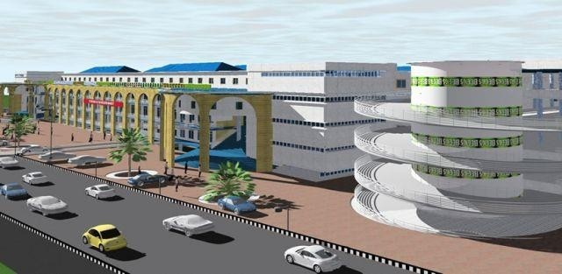

***A view of the proposed commercial centre***

**AIM**

In line with Sustainable Development Goal 11, this project aims to provide a green, resilient and smart Somolu LGA.

**OBJECTIVES**

1. To create commercial and multi-land use facilities in other to enhance financial freedom and

Self-sustainability.

1. Creating an optimum transport system taking advantage of the existing. Ikorodu, 3rd mainland

and Oworonshoki expresssways.

1. Enhancing pedestrianizing, cycling and development of existing and proposed circulation infrastructure,

in order to reduce the impact of carbon-emission.

4. To provide green infrastructure to mitigate urban heat island and the impact of climate change.

5. Reduce the impact of waste mismanagement through the provision of public waste disposal facilities

and recycling oriented processes.

6. Creation of Eco-techno environment for information technology.

7. Carrying out Urban renewal activities in the slum and swampy areas of Somolu LGA using the process of rehabilitation.

8. Adequate Provision and supply of portable clean water majorly for the residential districts in the Site area.

9. Strategic positioning of Infrastructures and facilities for the residents in the community

10. Reduce congestion and improve the performance of Somolu LGA

11. Intervene in informal settlements through phased improvements, development control measures and use cross-subsidy where appropriate.

12. Introduce a green network that capitalizes on existing waterways network and open spaces

**EVALUATION TABLE AND METRICS**

Both concepts are to help improve and focus on the most valuable direction at which development is moving and may possibly move to in the future. It shows that in the present concept A is really restricted to flexible development, and if need be, the towns would have to be restructured or renewed.

some parts of the built up areas known for some activities can be restructured or the unknown places within the built up areas can be allocated for distinctive purposes but not necessarily the north. Therefore, more attention

|  |  |  |
| --- | --- | --- |
|  |  |  |
|  | CRITERIA | WEIGHT |
| A | LAND USE LAYOUT |  |
|  | Accomplish optimum use of land | 3 |
|  | Compatibility of land use | 2 |
| B | ROAD NETWORK |  |
|  | Flexibility of Road network | 5 |
|  |  |  |
|  | Access to major road | 3 |
|  | Traffic carriage | 3 |
| C | COST IMPLICATION |  |
|  | Minimum development cost | 4 |
|  | Minimum cost of service | 3 |
|  | Minimum operational cost | 4 |
| D | SOCIAL AND ENVIRONMENTAL IMPACT |  |
|  | Aesthetics | 4 |
|  | Security | 3 |
|  | Minimum Eco Hazard | 3 |
|  | Eco friendly CBD with low carbon footprint | 3 |

should be placed on providing housing schemes, facilities and infrastructures that can accommodate the coming population. This is the method of evaluating a program by appointing the extent of the objectives, goal achievement, it uses monetary values and each goal is evaluated by several points in form of a matrix.

|  |  |  |  |  |  |  |  |  |  |
| --- | --- | --- | --- | --- | --- | --- | --- | --- | --- |
|  |  | |  |  | CONCEPT A | | CONCEPT B | | |
|  |  | |  |  |  | |  | | |
|  | CRITERIA | WEIGHT | |  | SCORE | WEIGHTED SCORE | SCORE | WEIGHTED SCORE | |
| A | LAND USE LAYOUT |  | |  |  |  |  | |  |
|  | Accomplish optimum use of land | 3 | |  | 2 | 6 | 2 | | 6 |
|  | Compatibility of land use | 2 | |  | 2 | 4 | 3 | | 4 |
|  | SUBTOTAL |  | |  |  | 10 |  | | 10 |
| B | ROAD NETWORK |  | |  |  |  |  | |  |
|  | Flexibility of Road network | 5 | |  | 4 | 20 | 3 | | 15 |
|  | Access to major road | 3 | |  | 3 | 9 | 1 | | 3 |
|  | Traffic carriage | 3 | |  | 3 | 9 | 2 | | 6 |
|  | SUBTOTAL |  | |  |  | 38 |  | | 24 |
| C | COST IMPLICATION |  | |  |  |  |  | |  |
|  | Minimum development cost | 4 | |  | 2 | 8 | 3 | | 12 |
|  | Minimum cost of service | 3 | |  | 3 | 9 | 3 | | 9 |
|  | Minimum operational cost | 4 | |  | 3 | 8 | 2 | | 8 |
|  | SUBTOTAL |  | |  |  | 25 |  | | 29 |
| D | SOCIAL IMPACT |  | |  |  |  |  | |  |
|  | Aesthetics | 4 | |  | 2 | 8 | 3 | | 12 |
|  | Security | 3 | |  | 2 | 6 | 3 | | 9 |
|  | Minimum Eco Hazard | 3 | |  | 1 | 3 | 3 | | 9 |
|  | Eco friendly CBD with low carbon footprint | 3 | |  | 1 | 3 | 3 | | 9 |
|  | SUBTOTAL |  | |  |  | 20 |  | | 39 |
|  | **TOTAL** |  | |  | 93 | | 101 | | |

**FINAL PROPOSALS**

This part shows the final land allocations made to the varying demands for land-use for the next 20 years. This goes to the extent at which the needed land was calculated to be able to meet up the required target. The existing land use serving as a bedrock for the needed land

uses, some have been charged for renewal and restructuring purposes while some are to occupy the virgin land for an existing purpose and future need. Both the renewed or restructured and the newly allocated have been integrated to the existing land-use. The renewed or restructured and new land-uses are as follows;

• PROPOSED COMMERCIAL BLOCK

• PROPOSED RECREATIONAL PARK

• PROPOSED RESIDENTIAL ESTATE

• PROPOSED PUBLIC UTILITIES (SCHOOLS, HEALTH CENTERS, CHILDREN PLAY GROUND, ETC.

• PROPOSED INFRASTRUCTURAL STATIONS

• PROPOSED TRANSIT TERMINALS

• PROPOSED WATER TRANSPOPRT SYSTEM

**PROPOSED COMMERCIAL BLOCK**

This area will primarily be composed [of commercial bui](https://en.wikipedia.org/wiki/Commerce)ldings, such as a ", [commercial strip,](https://en.wikipedia.org/wiki/The_Strip) or [shopping Centre. Com](https://en.wikipedia.org/wiki/Shopping_centre)mercial activity within the study area includes the buying and selling of goods and services in [retail busin](https://en.wikipedia.org/wiki/Retail)esses, [wholesale b](https://en.wikipedia.org/wiki/Wholesale)uying and selling, [financial establishments,](https://en.wikipedia.org/wiki/Finance) and a wide variety of uses that are broadly classified as "business." While commercial activities typically take up a relatively small amount of land, they are extremely important to a community’s [economy.](https://en.wikipedia.org/wiki/Economy) They provide [employment,](https://en.wikipedia.org/wiki/Employment) facilitate the circulation of money, and often serve many other roles important to the community, such as public gathering and cultural event.

A commercial area is real estate intended for use by for-profit businesses, such as office complexes, shopping malls, service stations and restaurants. It may be purchased outright by a developer for future projects or leased through a real estate broker. This type of property falls somewhere between residential and industrial property. Practically every incomer must grant permission to build a new office complex or other profit-making business, the city government must determine that the chosen area is indeed commercial area. The zones which separate

commercial, industrial, and residential area are clearly marked for commercial use, then the city will allow the sale to proceed for the stated use.

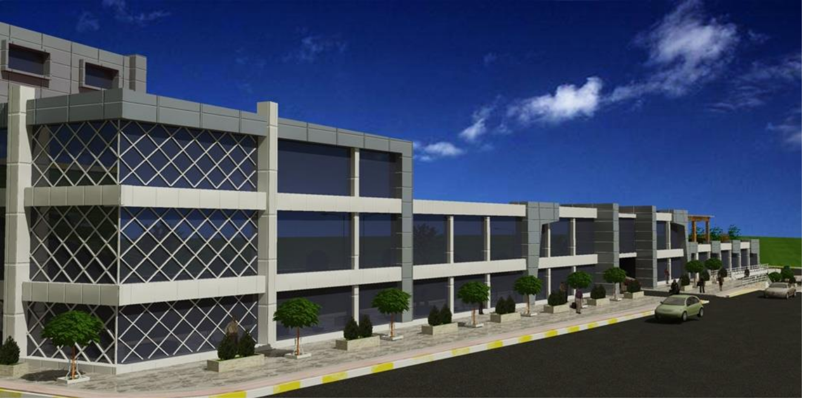

**PROPOSED COMMEFRCIAL BLOCK**

**BENEFITS OF THE COMMERCIAL BLOCK TO THE STUDY AREA**

1. Brings in revenue

2. Creates job opportunities (thus stemming the efflux of the workforce)

3. Generally, leads to improved infrastructure (commercial activities leads to better roads, electricity, water, etc.)

4. Increases associated business opportunities (due to higher purchasing power, dependent business activities, etc.)

5. To improve the income generated in the area and also the environmental scap

**PROPOSED RECREATIONAL PARK**

This will be located at a central area of the site area, the land use will involve the using of landscape designs for its proper planning and its element which are site furniture, water, vegetation, etc. to create a serene environment for people coming into shomolu to have fun with family and friends. This centre could also serve as a source of revenue for the government in this case whereby people who are coming in will be ask to pay a certain amount of money. Part of the money gotten here will be used for its maintenance

**CORNER SHOPS:**

These are small shops, especially on a corner of a road that sells food and other things that are often needed. It also serves as a medium to the people in the estate instead of seeking to get something as far as the shopping mall it could easily be gotten from these corner shops.

**FILLING STATION**

A *filling station* is a facility that sells fuel and engine lubricants for motor vehicles. There are 2 filling stations in the neighbourhood. The first filling station which is been sited at the entrance of the estate is being placed reason been that according to OBATERU its being stated that the filling station is to be sited at the entrance of a residential estate which is obviously close to the distributor road so as to serve both the people in the estate and also the outsiders passing that major road.

**BANK**

A bank is a financial institution that accepts deposits from the public and lends the fund to burrower. It serves as a platform for people in the neighbourhood to save their money security reasons and it’s been cited in the central area for equal access to all densities.

**REFUSE DEPOT**

This is a place where waste materials are being discharged. It is cited North-eastern part of the residential estate duel because of the breeze that blows from the north east trade wind and southwest monsoon wind won’t really blow the refuse smell that will affect the residences

**LIBRARY**

This is a collection of sources of information and similar resources, made accessible to the neighbourhood for reference or burrowing it is being located in the central area for easy access to the residence and also located close to the elementary school in order for the children to serve a s a means of seeking information on any of their school; activities

**FIRE STATION**

This is a body where their service is to extinguish fire whenever there is fire outbreak particularly within the residential estate area the service radius of a fire station is 800m and thus only one was proposed for the residential estate.

**CHILDREN PLAY GROUND**

This is also a recreational use which is being cited in various blocks so as to reduce the pressure being placed on the central park, according to **OBATERU** children playground should be cited in the middle of the block and not the corner of the block for safety reasons. It covers about four plots of land.

**PROPOSED WATER TRANSPOPRT SYSTEM**

This system involves the movement of large mass of people from one point of origin to another point of destination. Its advantages are:

1. Freight carrying capacity by water is more than ten folds higher than carrying capacity by road.

2. Fuel consumption per unit weight is very low

3. Operating cost per unit weight is very low

4. If the same quantity of goods is transported by road, greenhouse gas emissions would be high

5. Depending on the depth of the port variable capacities of vessels can be employed

6. Due to low operating costs and fuel consumption, international trade is comparatively cheaper.

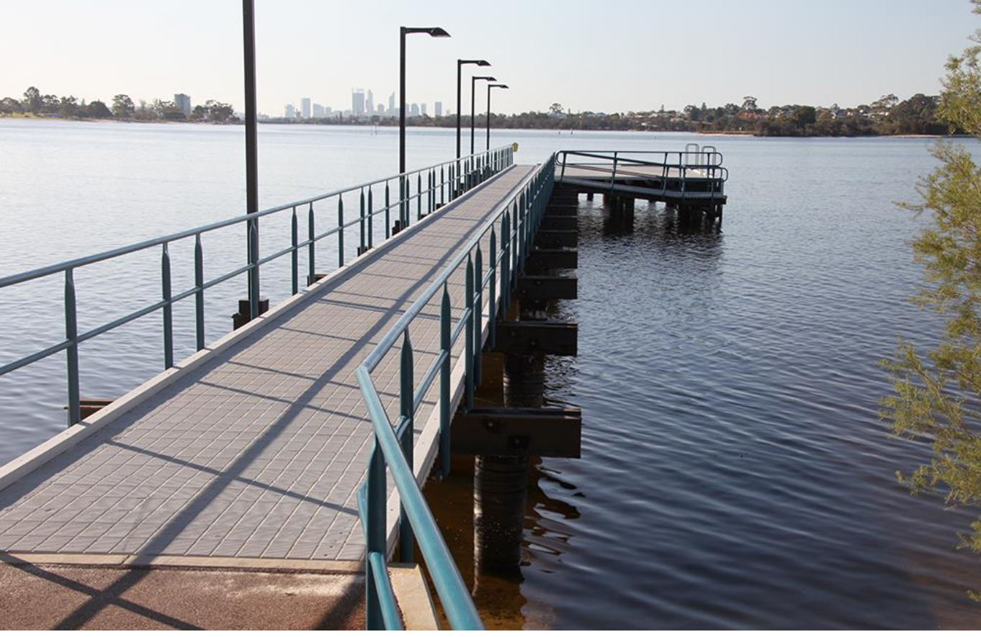

**A VIEW OF THE PROPOSED JETTY FOR TRANSPORTATION**

**SHOMOLU MASTER PLAN POLICIES (2018-2038)**

Master plan takes its origin from land use planning. It provides a long-term plan that helps in ordering and management of the use of land based on a detailed understanding and analysis of social needs, goals and objectives.

Though a master plan may be for a region or a state’s vision of the future development pattern and trends, it however serves as an essential framework for local growth and development. Furthermore, a master plan is a policy based document; it does not and cannot regulate the use of land. Also, it is not a zoning document. Consequently, the recommendations in a master plan are only meant for guidance and not for regulating properties or land uses.

The Master Plan Policies are intended to provide guidance in the evaluation of future decisions on land use, infrastructure improvements, transportation, and other issues, and ordinances that are proposed and considered after the adoption of the Master Plan Policies should be consistent with the relevant goals and policies contained in the Plan. If an ordinance instituting or modifying rules or regulations is being considered which is contrary to the goals and policies of the plan, either the plan should be reviewed and amended prior to the adoption of the ordinance, or it should be clearly stated what circumstances necessitate that it be in conflict with the plan.

Community planning is a continuous and dynamic process that helps the community achieves goals that are important to its citizens and to the community at large. Over time, these goals will likely change. Then, the community must again review where they have been, how they got there, what has changed since their last planning effort, and where they want to go next. This is a normal planning process, and it happens in all communities.

**ORGANIZATION OF THE MASTER PLAN POLICIES**

This plan is organized into three sections: Principles, Assumptions, Policies,

**3.1 PRINCIPLES**

This Master Plan is based upon several land use and land development principles. These Include:

1. Encouraging residential development in locations and at densities compatible with existing, or desirable, development patterns and that can be properly serviced by public roadways, utilities and services.

2. Locating public, business, light industrial, research, professional and office uses at sites and in locations that are suitable for their use environmentally, economically, geographically and aesthetically, and are compatible with existing uses, public facilities, roadways, natural features and neighbouring uses.

3. Protecting natural and environmental resources, including flood plains, wetlands, marsh and aquifer recharge areas, steep slopes, woodlands, and areas suitable for public and quasi-public recreational uses.

4. Encouraging a development pattern that will protect and enhance the long-term economic, social and welfare interests of present and future residents of the Township.

**3.2 ASSUMPTIONS**

This Master Plan is also based upon the following assumptions:

1. That there will be no catastrophic man-made or natural disasters that will greatly affect the existing natural or man-made development of the Township or the Township’s ability to implement the Master Plan.

2. That growth during the next twenty-year period will not exceed the capacity of the community to reasonably and economically provide essential community facilities, utilities, and/or services.

|  |  |  |  |  |
| --- | --- | --- | --- | --- |
|  | |  | |  |
|  | |  | |
|  | **PHASE 1**  **(5 YEARS)** |  | **DEVELOPMENT PROCESS** |
|  | • Grading and construction of distributor and access roads in  need of repair.  • Construction of drainages along renovated zone one distributor and access roads  • Incorporating green infrastructure (i.e. planting of trees and grasses in strategic locations in zone one.  • Construction of proposed commercial blocks in zone one.  • Development of parks and recreational facilities in zone one.  • Installation of street lights and traffic signs along distributor and access roads in zone one.   * Construction of water power plant and water distribution systems. | | |

**3.3 POLICIES**

This Master Plan for Shomolu (2018-2038) is based upon policies that have been developed by the

Planning Board and other land development review agencies:

1. Land use planning will provide for a variety of residential and non-residential uses that will encourage continuation and enhancement of the Township as a highly-desired, high quality, suburban residential community and will not negatively impact upon the aesthetics of the community.

2. The Township will consider and evaluate innovative development proposals that would enhance and protect quality of life and environmental features, minimize energy usage, and encourage development densities consistent with patterns of development envisioned by this Master Plan.

3. The Township and the Board of Education will maintain timely and effective communications regarding population growth and recreational and school facilities to ensure continuation of the high quality of educational and recreational systems.

4. The Township will encourage, and provide for, on-going review of evolving economic, social, health, welfare, safety, cultural, recreational, utilities, services, activities and needs within the Township to best serve the present and future needs of residents.

5. Land development will be designed and regulated to protect and enhance the environmental quality of the Township and its natural resources and to preserve or enhance the visual aesthetics of existing public facilities and green acres.

6. The Township will continue to review, update and supplement the Master Plan and the Land Use and Development ordinances and regulations as new data become available, and as community needs or circumstances may change.

**Image of final proposed map be pasted here in order for it to be wisely pasted here**

**PHASING AND IMPLEMENTATION**

|  |  |  |  |
| --- | --- | --- | --- |
| **PHASE 2**  **(5 YEARS)** |  | **DEVELOPMENT PROCESS** |  |
| • Grading and reconstruction of zone two distributor and access roads used in repair.  • Construction of drainages along renovated zone two distributor and access roads.  • Installation of street lights and traffic signs/signals along distributor and access roads in zone two.  • Incorporating green infrastructure in zone two (planting of trees and grasses in strategic locations.  • Construction of ultra- modern intra-state mass transit Bus Park in zone two.  • Development of parks and recreational facilities in zone two.  • Extensive dredging of Lagoon in preparation of urban renewal. | | |  |

|  |  |  |  |  |
| --- | --- | --- | --- | --- |
| **PHASE 3**  **(5 YEARS)** |  | **DEVELOPMENT PROCESS** |  |  |
| • Extensive development and completion of fast train terminals.  • Extensive grading and reconstruction of distributor and access roads to the need of repair.  • Construction of drainages along newly renovated distributor road and access roads.  • Installation of street lights and traffic signs/signals along distributor and access roads in zone five.  • Incorporating green infrastructures (i.e. planting of trees and grasses in strategic locations.  • Development of parks and recreational areas in the zones lacking these facilities  • Construction of Jetty linking shomolu and idumota, cms, Lagos Island. | | |  |

|  |  |  |  |  |  |
| --- | --- | --- | --- | --- | --- |
|  | **PHASE 4**  **(5 YEARS)** |  | **DEVELOPMENT PROCESS** |  | |
|  | • Extensive completion and development of all major distributor and access roads.  • Extensive development and completion of ultra-modern Bariga market.  • Full scale development and completion of proposed high rise residential estate in the urban renewal zone.  • Incorporating green infrastructure along st finbaars, and Ilaje road, which includes lining the roadsides with trees, royal palm to be precise  • Full repair of roads and drainages across the site area as well as installation of street lights and incorporating green infrastructures.  • Development of parks and recreational facilities the site area. | | |  |
|  | | | |  | |  |

**ENVIRONMENTAL IMPACT ASSESSMENT**

**WHAT IS ENVIRONMENTAL IMPACT ASSESSMENT?**

In a nut shell EIA is just an information gathering exercise carried out by the developer and other bodies which enables a Local Planning Authority to understand the environmental effects of a development before deciding whether or not it should go ahead. The really important thing about environmental assessments is the emphasis on using the best

available sources of objective information and in carrying out a systematic and holistic process which should be bias free and allow the local authority and the whole community to properly understand the impact of the proposed development. Environmental assessment should lead to better standards of development and in some cases development not happening at all. Where developments do go ahead environmental assessments should help to propose proper mitigation measures. Environmental impact assessment is meant to be a systematic process which leads to a final product, the Environmental Statement (ES).

**ORIGIN OF EIA**

Before the First World War, rapid industrialization and urbanization in western countries was causing rapid loss of natural resources. This continued to the period after the Second World War giving rise to concerns for pollution, quality of life and environmental stress. In early 60s, investors and people realized that the projects they were under taking were affecting the environment, resources, raw materials and people. As a result of this, pressure groups formed with the aim of getting a tool that can be used to safeguard the environment in any development. The USA decided to respond to these issues and established a National Environmental Policy Act in 1970 to consider its goal in terms of environmental protection. The USA became the first country to enact legislation on EIA. This was the first time that EIA became the official tool to be used to protect the environment. The United Nations Conference on the Environment in Stockholm in 1972 and subsequent conventions formalized EIA. At present, all developed countries have environmental laws whereas most of the developing countries are still adopting it (Lee, 1995) Multilateral and bilateral lenders included EIA requirements in their project eligibility criteria (OECD, 1996).

**ENVIRONMENTAL IMPACT ASSESSMENT (EIA) PROCESS**

The first phase of an environmental assessment is called an Initial Environmental Examination (IEE) and the second is Environmental Impact Studies (EIS) or simply detailed EIA.

a) **INITIAL ENVIRONMENTAL EXAMINATION (IEE)**

IEE is carried out to determine whether potentially adverse environmental effects are significant ant or whether mitigation measures can be adopted to reduce or eliminate these adverse effects. The IEE contains a brief statement of key environmental issues, based on readily available information, and is used in the early (pre-feasibility) phase of project planning. The IEE also suggests whether in-depth studies are needed. When an IEE is able to provide a definite solution to environmental problems, an EIA is not necessary. IEE also requires expert advice and technical input from environmental specialists so that potential environmental problems can be clearly defined.

b) **ENVIRONMENTAL IMPACT STUDIES (EIS)**

EIA is a procedure used to examine the environmental consequences or impacts, both beneficial and adverse, of a proposed development project and to ensure that these effects are taken into account in project design. The EIA is therefore based on predictions. These impacts can include all relevant aspects of the natural, social, economic and human environment. The study therefore requires a multi- disciplinary approach and should be done very early the feasibility stage of a project. In other words, a project should be assessed for its environmental feasibility. A should therefore be viewed as an integral part of the project planning process. Unlike the environmental audit (EA), which is conducted on existing projects, the EIA is applied to new projects and the expansion aspects of existing projects. The phases of an EIA from screening to follow-up are illustrated in Figure 1 below



